Access Dispute Resolution Rules
Joint Reference Submission to
Timetabling Panel TTP100 re
Service in Connection with
Wootton Bassett Renewal August 2006

Network Rail
First Great Western

- 1 details of parties
  - 1.1 The names and addresses of the parties to the reference are as follows:-
    - First Greater Western Ltd., whose Registered Office is at Milford House, 1 Milford Street, Swindon SN1 1HL (“FGW” ("the Claimant")); and
    - Network Rail Infrastructure Ltd, whose Registered Office is at 40 Melton Street, London NW1 2EE (“NR” (“the Respondent”))

- The Parties’ right to bring this reference
  - This matter is referred to a Timetabling Panel ("the Panel") for determination in accordance with Condition 5.1.1.1 (c) of Part D the Network Code.
  - Part D of the Network Code includes the following relevant conditions:

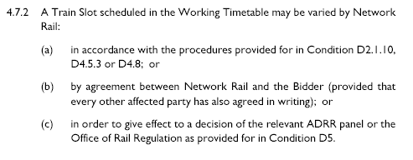

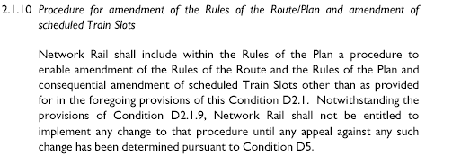

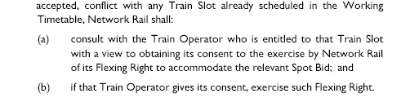

D4.8 is the Supplementary Timetable Revision Process;

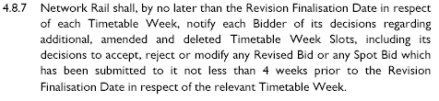

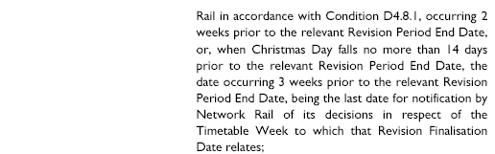

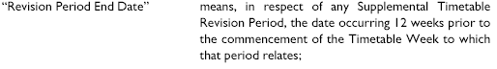

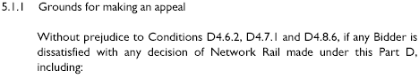

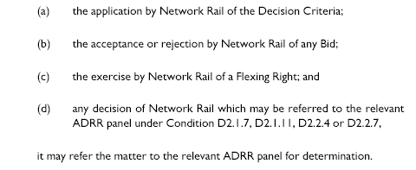
- Contents of reference

The Parties have together produced this joint reference and it includes:-
    - The subject matter of the dispute in Section 4;
    - A summary of the issues in dispute in Section 5;
    - A detailed explanation of the issues in dispute prepared by the claimant with a paragraph by paragraph response from the respondent(s) in Section 6;
    - Any further issues raised by the respondent in Section 7;
    - The decisions of principle sought from the Panel in respect of legal entitlement and remedies in Section 8; and
    - Appendices and other supporting material.

- subject matter of dispute

4.1 This referral arises because FGW disputes NR alleged right to flex its services after the date by which FGW believes the deadline for such flexing right has passed.

It concerns the flexing of three FGW services already diverted via the Berks and Hants as a result of the renewal of Wootton Bassett Junction and the flexing of an FGW normally operating on the route.

The diversions are occurring as a result of a possession that is taking place in August rather than at Christmas mainly in order to assist the maintenance of coal traffic to Didcot Power station during the winter months. Trains already diverted because of this are now being retimed to accommodate a stone train operated, FGW believes, by the same freight company.

The FGW trains diverted are key long distance commuter and business services from South Wales and the Bristol area to Reading and London and have extended journey times, some by an hour or so. The new timings add a further 12 minutes to one, 4 to another and 6 to a third. In addition they add 8 minutes to a previously unaffected Bedwyn - Newbury - Paddington service. These further retimings will require some minor adjustment to driver diagrams as one break is broken by the further delay.

4.2 The FGW diversionary paths were offered by NR on 7th July. These were accepted by FGW and published. All trains included in the offer to FGW were offered such that “all of these schedules have been accepted and published today”. It also contained a caveat that due to “some outstanding discrepancies with the Freight Company’s Offer all the attached timings may be subject to change and FGW will be notified accordingly if this occurs.”

On 18th August (after the timetable for the days of implementation, Tuesday 29th August to 1st September had been published in public pamphlets and on FGW’s website) NR sought to seek FGW’s permission for further retimings. This was rejected the same day on the grounds of additional delay to services already published.

FGW believes there is no scope for such retimings to be imposed given FGW’s rejection and clauses 4.8.7 and 4.7.2 which it believes taken together show the deadline for such changes as a result of a possession already declared and planned under the supplementary timetable process as this was is seven weeks prior to implementation.

- summary of dispute

Network Rail believes that in caveating the 7th July offer to FGW that further freight service validation might impact upon FGW services, the decisions notified to FGW on the 18th August are valid and the subsequent retimings of 4 FGW services should be accepted. [Please see Appendix 1 e-mail]

FGW, however, believe that this imposition of retimings on 4 services is unacceptable at this stage of the process. [Please see Appendix 2 e-mail]
- explanation of each issue in dispute with response
EWS have level one contractual rights to a Westbury to Acton freight service (7A09). This train runs SX and loads to over 4,000t and thus is a difficult service to path. The level 1 rights are for an 11.30 arrival at Acton with a flex of plus/minus 30 minutes.
Network Rail has worked hard to satisfy all parties contractual rights and in doing so believes that the amendment to the 4 FGW services are in line with the caveat attached to the 7th July offer.
The Operational Planning teams are working hard to see if a further amendment can be made to the 7A09 path to enable a reduction in the retimings to the FGW services.

The 4 trains in question have been retimed as follows:-
- 1Z84 06.38 Swansea to Paddington willl now arrive Paddington 12 minutes later than previously advised.
- 7A09 06.56 Merehead to Acton has been retimed all the way to Acton arriving 15 minutes later than booked.
2K31 Bedwyn to Reading arrives Reading 8 minutes later
- 1A84 07.35 Plymouth to Paddington arrives Paddington 4 minutes later
- 1A11 09.30 Bristol to Paddington arrives Paddington 6 minutes later

The retimings apply for 4 days next week Tuesday to Friday and NR have offered to publically advertise the services in line with FGW publicity.

If 7A09 is late then it will be regulated to minimise overall delay and if it loads to a lighter weight than timetabled then it arrive at the key location of Hungerford earlier and 1Z84 will run early from that point.

- any further issues raised

- decision sought from the PANEL
  - The Panel is asked by FGW to determine:

that NR has no power to impose the retimings sought on 18th August, and that timings issued on 7th July and currently implemented should apply in the wtt for the four days concerned.

8.2 The Panel is asked by NR to ratify that NR has correctly applied the flexing right as per the Decision Criteria and that the amended timings provided subsequent to the caveatted offer on 7th July should apply next week.

signatures

For and on behalf of l For and on behalf of l

Signed Signed

Print name Print name
Position: Position:

Date: Date:

- Appendices and Annexes

Appendix 1 – copy of e-mail from Network Rail to FGW caveating the 7th July offer

Appendix 2 – copy of e-mail from FGW to Network Rail rejecting the changes

