Sole Reference Submission to Timetabling Panel
Stagecoach South Western Trains Ltd
TTP1072
28th March 2017

- Details of parties
  - The names and addresses of the parties to the reference are as follows:-
    - Stagecoach South Western Trains Ltd whose registered address is Friars Bridge Court, 41-45 Blackfriars Road, London, SE1 8NZ "SSWT" ("the Claimant"); and
    - Network Rail Infrastructure Limited whose Registered Office is at 1 Eversholt Street, London NW1 2DN “Network Rail" ("the Defendant")
    - SSWT contact details: Joanna Davey, Train Planning Manager, Friars Bridge Court, 41-45 Blackfriars Road, London, SE1 8NZ
- The Claimant’s’ right to bring this reference
  - This matter is referred to a Timetabling Panel ("the Panel") for determination in accordance with Condition D5, 2.2.8(b) of the Network Code, Part D.

In accordance with the above condition, SSWT has disputed certain elements of the decision document (otherwise known as Version 2 of the ‘Rules’ for 2018) in line witrh the 15 day working days prescribed.
- Contents of reference

This Sole Reference includes:-
    - The subject matter of the dispute in Section 4;
    - A detailed explanation of the issues in dispute in Section 5;
    - In Section 6, the decisions sought from the Panel in respect of
      - legal entitlement, and
      - remedies;
    - Appendices and other supporting material.

- subject matter of dispute
  - This is a dispute regarding some elements of the Timetable Planning Rules (TPR’s) for the Wessex route contained within Version 2 of the Rules.
  - This dispute arises over the interpretation of the Decision Criteria as detailed in Network Code Part D Clause 4.6.2 of the Network Code.

Part D Clause 4.6.2 Decision Criteria items (b), (c), (d), (e) and (j) have not been fully considered at this stage
(b) that the spread of service reflects demand
(c) maintaining and improving train service performance;
(d) that journey times are as short as reasonably possible;
(e) maintaining and improving an integrated system of transport for passengers and goods;
(j) enabling operators of trains to utilise their assets

efficiently

4.3 SSWT believes that the TPR’s as published in Version 2 of the ‘Rules’ do not reflect agreed amendments that have been negotiated between Network Rail & SSWT prior to their publication, specifically around the ‘TRIP’ program of amendments. Details of these are provided in Appendix A. SSWT believes that by failing to accurately document these agreements, Network Rail has failed to consider those Decision Criteria cited above, in that were the TPR’s to be applied as they remain published in Version 2 of the Rules, capacity on the Wessex network would be eroded resulting in the removal train paths which SSWT cannot accept.

- explanation of each issue in dispute and the Claimant’s Arguments to support its Case
  - Worting Junction

The proposal within Version 1 of the TPR’s to increase the junction margin at the above location for converging movements from 3 to 4 minutes, was rejected via negotiation with Network Rail representatives from the ‘TRIP’ program (Appendix B which shows minutes from a meeting on 5th January 2017 which clearly marks this proposal ‘removed’). This was decided due to the potential to erode existing capacity were it to be applied to the Timetable.

Since this dispute was registered at ADRC, Network Rail has issued a consultation document to remove the above from Version 3 of the ‘Rules’ which will satisfy SSWT’s dispute, however this will not be formally issued until 31/03/17, 3 days after the required submission date for this supporting paper. Therefore SSWT cannot safely remove its dispute until Version 3 is issued.
  - Eastleigh

The proposal within Version 1 of the TPR’s to increase some of the junction margins from 3 to 4 / 4.5 / 5 minutes at the above location for, was rejected via negotiation with Network Rail representatives from the ‘TRIP’ program (Appendix B which shows minutes from a meeting on 5th January 2017 which clearly marks this proposal ‘derogate’, meaning to be removed). This was decided due to the impact study undertaken demonstrating that to apply the rule would necessitate removal of existing train paths were it to be applied to the Timetable.

Since this dispute was registered at ADRC, Network Rail has issued a consultation document to remove the above from Version 3 of the ‘Rules’ which will satisfy SSWT’s dispute, however this will not be formally issued until 31/03/17, 3 days after the required submission date for this supporting paper. Therefore SSWT cannot safely remove its dispute until Version 3 is issued.
  - Shawford

The proposal within Version 1 of the TPR’s to amend the notes section of the margin to apply a stop at Shawford station – this was inaccurate and needed to reflect stopping at the agreed signal.

Since this dispute was registered at ADRC, Network Rail has issued a consultation document to remove the above from Version 3 of the ‘Rules’ which will satisfy SSSWT’s dispute, however this will not be formally issued until 31/03/17, 3 days after the required submission date for this supporting paper. Therefore SSWT cannot safely remove its dispute until Version 3 is issued.
  - Romsey

The proposal within Version 1 of the TPR’s to amend a variety of the junction margins from 3 to 4 / 4.5 / 2 minutes at the above location for, was rejected via negotiation with Network Rail representatives from the ‘TRIP’ program and the local signalling experts.

Since this dispute was registered at ADRC, Network Rail has issued a consultation document to remove the above from Version 3 of the ‘Rules’ which will satisfy SSWT’s dispute, however this will not be formally issued until 31/03/17, 3 days after the required submission date for this supporting paper. Therefore SSWT cannot safely remove its dispute until Version 3 is issued.

5.5 Guildford

The proposal within Version 1 of the TPR’s to increase some of the junction margins from 3 to 2.5 / 4 / 4.5 / 5 minutes at the above location for, was rejected via negotiation with Network Rail representatives from the ‘TRIP’ program. This was decided due to the impact study undertaken demonstrating that to apply the rule would potentially necessitate removal of existing train paths / negatively impact the performance of the network were it to be applied to the Timetable.

Since this dispute was registered at ADRC, Network Rail has issued a consultation document to remove the above from Version 3 of the ‘Rules’ which will satisfy SSWT’s dispute, however this will not be formally issued until 31/03/17, 3 days after the required submission date for this supporting paper. Therefore SSWT cannot safely remove its dispute until Version 3 is issued.

5.6 Portsmouth & Southsea

The proposal within Version 1 of the TPR’s to increase some of the junction margins from 3 to 2.5 / 4 / 4.5 minutes at the above location for, was rejected via negotiation with Network Rail representatives from the ‘TRIP’ program. This was decided due to the impact study undertaken demonstrating that to apply the rule would potentially necessitate removal of existing train paths / negatively impact the performance of the network were it to be applied to the Timetable.

Since this dispute was registered at ADRC, Network Rail has issued a consultation document to remove the above from Version 3 of the ‘Rules’ which will satisfy SSWT’s dispute, however this will not be formally issued until 31/03/17, 3 days after the required submission date for this supporting paper. Therefore SSWT cannot safely remove its dispute until Version 3 is issued.

5.7 Waterloo

The rules at Waterloo were changed in consultation with SSWT at the publication of Version 2, however the changes were not all made accurately meaning there were duplicate & conflicting entries for some platform reoccupation times, and conflicting information regarding the ability to use platforms 20 to 22 when compared with the Engineering Access Statement.

Since this dispute was registered at ADRC, Network Rail has issued a consultation document to remove the above from Version 3 of the ‘Rules’ which will satisfy SSWT’s dispute, however this will not be formally issued until 31/03/17, 3 days after the required submission date for this supporting paper. Therefore SSWT cannot safely remove its dispute until Version 3 is issued.

- decision sought from the PANEL
  - The Panel is asked to determine that the amendments outlined in Network Rail’s consultation document, issued on 24/03/17 and due to appear in Version 3 of the Rules, will be upheld in the unlikely event that any other party disputes these changes via the consultation process. For information this is supplied as Appendix C.

- Appendices
The Claimant confirms that it has complied with Access Dispute Resolution Rule H21
All appendices are bound into the submission, and consecutively page numbered. To assist the Panel, quotations or references that are cited in the formal submission are highlighted (or side-lined) so that the context of the quotation or reference is apparent.
Any information only made available after the main submission has been submitted to the Panel will be consecutively numbered, so as to follow on at the conclusion of the previous submission.

- signature
For and on behalf of Stagecoach South Western Trains Limited

___________________________________
Signed

-----------------------------------------------------------
Print Name
Joanna Davey
___________________________________
Position
Train Planning Manager
___________________________________

The Appendices

Appendix A – Dispute items

London Waterloo

Worting Jn

Shawford Jn

Eastleigh

Portsmouth & Southsea

Guildford

Romsey

Appendix B – TRIP minutes

TRIP latest summary document 24-02-17.xls

Appendix C – Network Rail consultation 24/03/2017


Amendment the Wessex Timetable Planning Rules 2018
Version 2.1

Final revised Rules for Principal Change Timetable 2018

Worting Junction
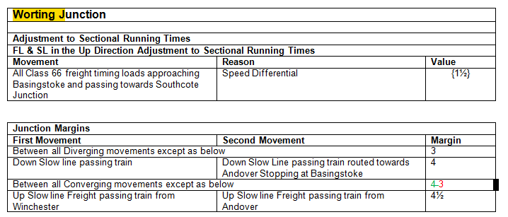
Change: Converging Margin changed from 4 min to 3 Min
Reason: Following the output of a study into the impact of these values, it has been concluded that the proposal will have a negative impact on the delivery of the Track Access Agreement between Network Rail and Timetable Participants.

Shawford Junction
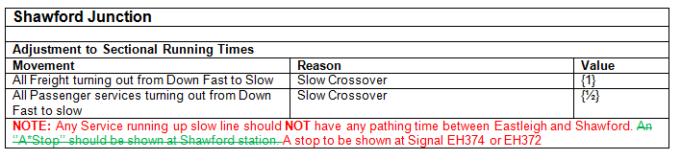
Change: Text instructing to show a stop has been replaced with the correct Signal
Reason: There no reason for showing a stop at Shawford, when the correct geography exists at the signal.

Eastleigh:
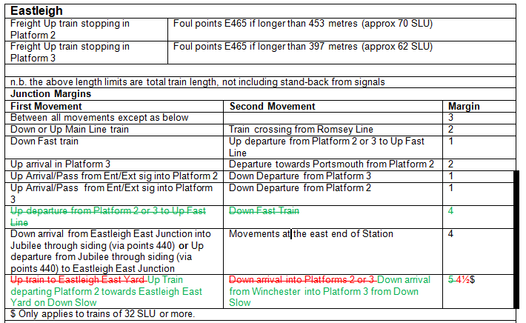

Change 1: Removal of the 4 min Trip Proposal Above.
Reason1: Following the output of a study into the impact of these values, it has been concluded that the proposal will have a negative impact on the delivery of the Track Access Agreement between Network Rail and Timetable Participants.
Change 2: Tidying up the wording for the margin to Eastleigh east Yard and reduction to the Margin from 5min to 4min 30 Sec
Reason2: Wording needed clarification and following the output of a study into the impact of these values, it has been concluded that the proposal will have a negative impact on the delivery of the Track Access Agreement between Network Rail and Timetable Participants.

Romsey:
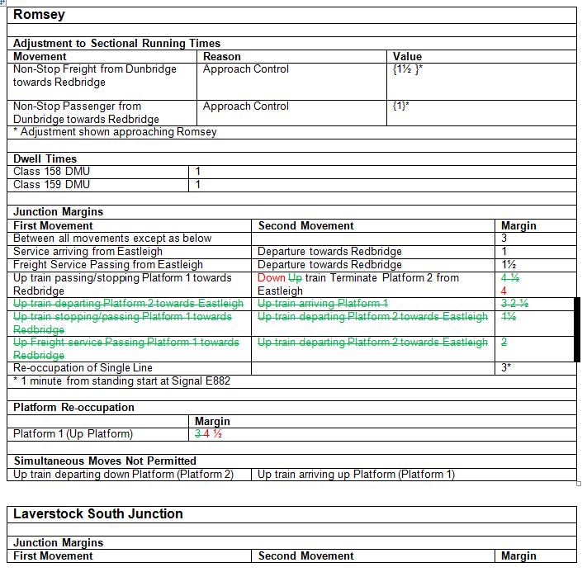
Change 1: Amendment to Text and Reduction in Margin from 4min 30 sec for 4min.
Reason 1: Wording needed clarification and following the output of a study into the impact of these values, it has been concluded that the proposal will have a negative impact on the delivery of the Track Access Agreement between Network Rail and Timetable Participants.

Change 2:Removal of 3 TRIP values
Reason 2: Following the output of a study into the impact of these values, it has been concluded that the proposal will have a negative impact on the delivery of the Track Access Agreement between Network Rail and Timetable Participants.
Change 3: increase in Platform Reoccupation
Reason 3: Network Rail impact assessments support the inclusion of this increase without compromising capacity.
Guildford:
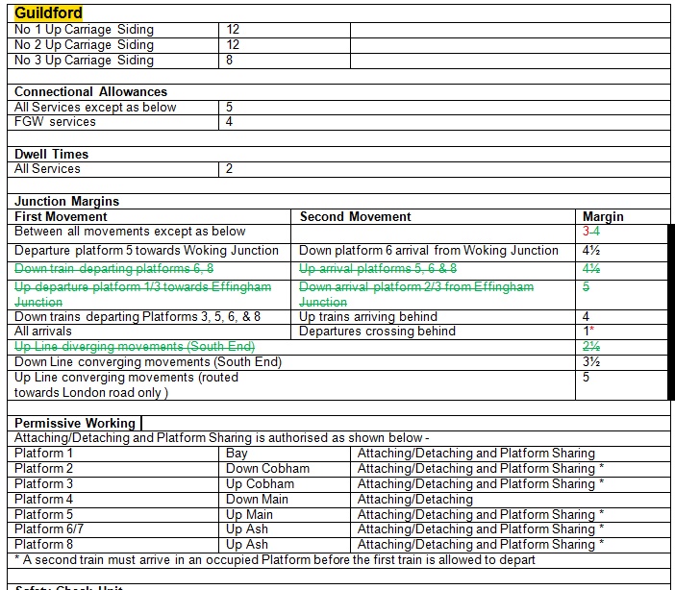

Change: Removal of 4 TRIP proposals
Reason: Following the output of a study into the impact of these values, it has been concluded that the proposal will have a negative impact on the delivery of the Track Access Agreement between Network Rail and Timetable Participants.
Portsmouth and Southsea
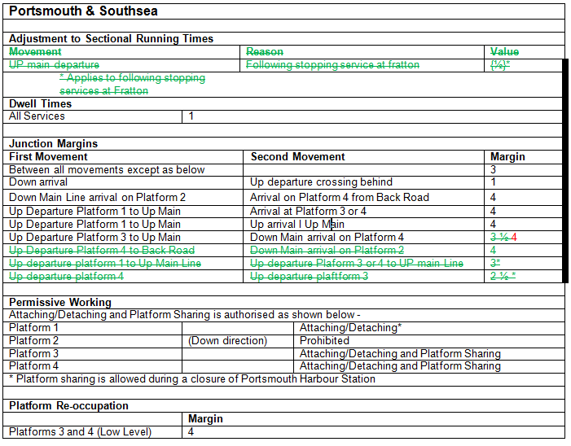

Change 1: Removal of Adjustment to sectional running times and the removal of a further three Margins.

Reason 1: Following the output of a study into the impact of these values, it has been concluded that the proposal will have a negative impact on the delivery of the Track Access Agreement between Network Rail and Timetable Participants.

Change 2: Increase of margin from 3min 30 seconds to 4 minutes

Reason 2: Network Rail impact assessments support the inclusion of this increase without compromising capacity.

Waterloo

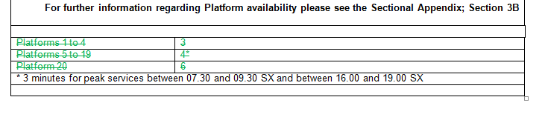
Change: Removal of margins at waterloo

Reason: These are superseded by the new margins at Waterloo consulted for Version 2

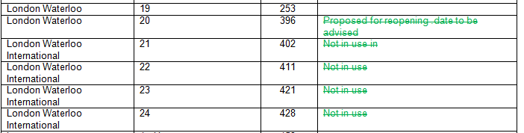

Change: Removal of notes allocated to platforms 20-24

Reason: Notes are no longer accurate; these platforms will be available under perturbation which is detailed in the EAS under Sections C (Restriction of use)

Best Regards,

Bruno Afonso
Capacity Planning Specialist
Wessex

