1 details of parties

1.1 The names and addresses of the party to the separate reference are as follows:-

(a) {Virgin} West Coast Trains Ltd. whose Registered Office is at 120 Campden Hill Road, London, W8 7AR ("WCTL") ("the Claimant");

(b) Correspondence Address: Virgin Trains Commercial Department, Room 15, North Wing Offices, Euston Station, London NW1 2HS.

2 The Parties’ right to bring this reference

2.1 These matters are referred to the Timetabling Panel ("the Panel") for determination in accordance with condition D3.5.4 of the National Rules of the Plan and Conditions D.2.1.11b and D.5.1 of the Network Code.

3 Contents of reference

The Parties have been advised that due to time considerations, each proposes its own individual reference rather than a joint reference and as such includes:-

(a) The subject matter of the dispute in Section 4;

(b) A summary of the issues in dispute in Section 5;

(c) A detailed explanation of the issues in dispute prepared by the claimant in Section 6;

(d) Section 7 Not Applicable;

(e) The decisions of principle sought from the Panel in respect of legal entitlement and remedies in Section 8; and

(f) Appendices and other supporting material.

4 subject matter of dispute

4.1 The principle issue regarding West Coast Trains Ltd. dispute is the affect of the proposed possession plan [NAUM-30] on its business and operations throughout the remaining part of this year and into 2009. WCTL does not consider that Network Rail, in consideration of its proposals and indeed WCTL response to the Preliminary Proposal(s) [NAUM-13], and in association with our previous response to Network Rail’s West Coast Route Modernisation [WCRM] Delivery Plan (drafted as a consequence of the Office of the Rail Regulator [ORR] Provisional Order on Network Rail), and as explained in detail in sections 5 to 6 below, has applied certain crucial elements of Decision Criteria reasonably, such that we will not be able to operate those services as contained within and supported through, WCTL current Firm Access Rights¹ (Best Achievable Access Rights [BAARS]), and the obvious consequential affects as such, on WCTL business.

4.2 Section 7 additionally contains specific items of dispute in conjunction with individual possessions and covers issues not directly related to Decision Criteria. There is also a section on potentially clashing possessions which have a direct impact on WCTL ability to operate robustly ‘over and above’ the affects of NAUM-30 proposed possessions. The principle of a lack of diversionary and non WCML route capability information also forms part of this section.

4.3 The Parts / Conditions that this dispute relate to or are associated with, is the reasonable application of specific elements of the Network Code in particular, the reasonable application of Decision Criteria [D.6] in conjunction with parts D2.10; D2.1.11(ii) and D.5.1 and sections 3.1, 3.4 & 3.5 of the National Rules of the Plan {2008}, especially when considered against the overall affect to the business, operations and delivery of WCTL train services.

4.4 Copies of the relevant extract(s) from the document(s) referred to above are attached as Annex “A”.

4.5 Annexes B to J are also attached below for reference purposes, and are accordingly referenced throughout sections 5 - 7 below, indexed accordingly under section 10.

¹ WCTL Firm Access Rights are currently expressed within a BAARS-10 Agreement which operates from May 18th until 13th December 2008. After this date it is currently envisaged that our new ‘Very High Frequency’ [VHF] timetable, implemented through the introduction of a complete new set of Firm Access Rights, subject to, but without prejudice to, the ensuing Industry wide consultation process being undertaken by the ORR, through WCTL recently submitted Section 18 application.

5 summary of dispute (background)

5.1 As one consequence of the overrunning WCRM Engineering works at the start of this year, and in conjunction with a subsequently detailed investigation into those reasons for such an overrun as led by the ORR², it was announced that, through the serving of a Provisional Order on Network Rail in February 2008, that Network Rail would need to formulate a WCRM Upgrade Delivery Plan by the end of March 2008, such plan able to adequately demonstrate the methodology and strategy necessary to deliver robustly and safely, all the remaining West Coast Main Line [WCML] Upgrade Works.

5.2 Such a plan to which all affected parties would be able to respond, was presented to the Industry during March, and included a range of Options [A, B & C] which would, if implemented, deliver those infrastructure works necessary to complete the West Coast Upgrade. Each of the three options presented, offered different solutions with two different completion dates – either 8th December 2008³ (Options ‘A’ or ‘B’) or 17th May 2009 (Option ‘C’) – See Annex “B” for full details of these Options.

5.3 In response to the ORR’s order, Network Rail initiated discussions with affected parties including ourselves, either through the wider forum of the West Coast Project Board or through Individual bi-lateral meetings. It was through such sessions that WCTL insisted upon Network Rail that whatever solution was to be adopted, it must adhere to our contractual obligations (including the ability to operate our Firm Access Rights [BAARS10], alongside the carrying out of our reasonable operating & business expectations, in union with those interests of our travelling passengers.

5.4 After such deliberations as outlined above, and after due consideration of WCTL response to Network Rail’s overall Delivery Plan, Network Rail decided that the Industry should adopt Option ‘B’. In cognisant of this particular dispute paper, Option ‘B’ therefore represents those possession proposals presented within the initially proposed NAUM-13 (Preliminary Proposal(s) – dated 12th March 2008) and consequently (to which this dispute relates), the Final Decision Proposal(s) NAUM30 - dated 2nd April 2008).

² WCTL requested of the ORR in early January 2008, that they consider the merits of a Provisional Order under Section 55 of the Railway’s Act, requiring Network Rail to provide a robust plan that would clearly demonstrate its ability to not only deliver the Upgrade works, but also maintain the WCML once complete. Such a plan would need to clearly set out all the possessions required, with a risk assessment for each site and the mitigation measures and contingencies needed to be put in place, necessary for delivery. The plan presented would have to give WCTL the confidence that they could plan their business properly and secure public interest going forward.

³ Due to Major Engineering Works in the Milton Keynes Area during Christmas & New Year 2008/09, it is acknowledged that the VHF timetable will not actually be introduced in earnest until 5th January 2009.

5.5 The possession proposals that form Option “B”, represent Network Rail’s preferred Delivery Plan for December 2008. In consideration of such proposals Network Rail have not, as far as WCTL are concerned; neither:

a) taken cognisant of those comments put forward by us in our response to the overall

Delivery Plan, nor ……..

b) reasonably considered our comments in response to NAUM-30 – {See Annexes C & D}

5.6 Such comments relate to an unreasonable application of Decision Criteria by Network Rail, when considering WCTL inability to:

i) Comply with Informed Traveller timescales for Period “D” & the process associated with implementing FIREWALL possessions D.6(c);

ii) Operate all its Firm Contractual Access Rights D.6(c);

iii) Maintain and improve its levels of Performance D.6(d)

iv) Maintain Connections between its & other Operator’s services D.6(f);

v) Avoid a material deterioration of its service patterns & frequencies D.6(g);

vi) On occasion, the even spread of passengers vs. an uneven spread of services D.6(h);

vii) Utilise its assets efficiently, without the need to increase such assets D.6(j)

5.7 The majority of possession proposals require the closure of the WCML South of Crewe, including a number of weekday requirements, and thus constitute to one of the most important issues of this dispute for WCTL. Although the Upgrade is obviously recognised as a major benefit for the Industry in general, it is essential to introduce such benefits in a safe and robust manner. One of our previous fundamental rejections of Option “B”, is due to the impact on our Driver Training programme, which although not able to be made specifically the subject matter of this dispute, does infer Network Rail’s disregard of certain Decision Criteria.

5.6 The majority of possessions as proposed under NAUM-30 have been disputed on the basis of a number of comparable Decision Criteria issues (5.6 above refer), which in view of the timescales prior to the hearing and the sheer volume of possession proposals in dispute, are detailed for ease of reference under each Decision Criteria item within Section 6 below. However, specific issues pertinent to individual possession proposals including clashing possessions, are outlined for clarity in section 7.

6 explanation of each issue in dispute (To be used with Annexes “C to E”)

“Whilst being conscious that no individual Decision Criteria has precedence over any others, and that all issues outlined below will be integral to one another, WCTL nonetheless attempts to provide evidence that Network Rail, in assessing the various Options available to them, as well as taking cognisant of the consultation and responses associated with the initial Delivery Plan, and, as a consequence, its presiding position regarding the possessions proposed through NAUM-30 (and initially NAUM-13), and thus forming the subject matter of this dispute, have taken no reasonable regard to the overall impact to WCTL business and operations, and as such reflects, in WCTL view, an unacceptable regard to various elements of Decision Criteria”.

6.1. Decision Criteria D.6(a)

6.1.1 This general item concerns all those possession proposals hereby disputed, and is pertinent to a general point regarding Network Rail’s lack of consideration regarding “Safety of the Network” in conjunction with WCTL Driver Training requirements⁴; WCTL has already rejected and shared with Network Rail (Annex “E” refers) its views regarding this issue, a point that we believe, will be further exacerbated through the fact that under this Option ‘B’, a number of iterative driver training schemes will need to be underway at the same time, (appropriate to the number of intermediate infrastructure layouts liable to be in place at any one time).

6.1.2 Furthermore ….”the sharing of capacity and securing the development of the Network for the carriage of passengers in the most efficient and economical manner in the interests of all users of railway services”….is not valid due to the need to significantly reduce our timetable plan (approx 43 full & 16 part cancellations each SX day) in order to release sufficient numbers of drivers for a total of up to three months. How can this be defined as ….”efficient and economical”…. when the eventual output not only considerably disrupts our business market (not only to those that travel on the day, but also the long term affect on market growth), but would also have a significant overcrowding affect on those remaining WCTL daytime services such that it would import additional safety risk to staff and travelling public alike, as well as the affect of increased road congestion and its potentially economic influence on national business; environmental pollution – more cars & increased air travel, etc.

⁴ For clarity purposes, although not specifically related to “Major” enhancement and/or re-signalling proposals south of Stafford, any possession proposal in relation to “Line Speed Enhancement” work, will also potentially have an affect on such driver training programme(s).

6.1.3 Such possession proposals could also import risk to the maintenance and renewal requirements elsewhere on the WCML, due to a requirement to transfer resources and equipment to those priority possession requirements. Despite a request for a full and explicit understanding of the impact of such proposals in our original pursuit of the Delivery Plan, we still do not fully understand the potential risk(s) to ongoing “Day to Day” infrastructure management over the WCML.

6.1.4 All of the above suggests to WCTL, that Network Rail have not, in light of the particular circumstances surrounding each ‘Final Decision’ proposal, reasonably considered the wider, operational, safety and economic implications and/or risks associated with the majority of those possessions contained within NAUM-30.

6.2. Decision Criteria D.6(c)

6.2.1 This particular matter, relative to such possessions as proposed in the earlier part of NAUM-30, as well as relevant to all “FIREWALL” Possession proposals, focuses on WCTL inability to comply with the Informed Traveller process, and its applicable deadline requirements as a direct result of proposals being proposed past the T-12 cut-off. This has a fundamental affect on the ability to comply with our Passenger Licence Conditions⁵ especially in consideration of not being able to permit reservations to be made on trains, due to a lack of timetable information and, as consequence of such actions, putting severe restrictions on the availability of reduced rate value tickets. Such actions therefore also jeopardise certain obligations contained in our Franchise Agreement⁵, particularly under Schedules 1.2.8 and 1.4.

6.2.2 Aside from the fact that Network Rail will be in breach of their Licence Condition Part 9, they will also, not be in the otherwise acceptable position to instigate those “Procedures for Altering Rules of the Route/Plan other than through the Twice Yearly Process having effect from a Principal and/or Subsidiary Change Date” (PARTP) where Network Rail ….” is committed to the achievement of the Informed Traveller deadlines resulting in details of amended train services being available 12 weeks before the date of Operation”.

⁵ Information included for supporting purposes only – no Annexed details apply.

6.2.3 Possessions which have been incorporated within NAUM-30 but which are expected to be implemented with less than 12 weeks notice, are not acceptable to WCTL, not only for the non compliance issues outlined above, but primarily also because of the impact on the timetable and the obvious disruption caused to our passengers, operations and resource management. Such possessions if agreed (Option “B”), would require WCTL to cancel / amend numerous services over the period from June to August (see 6.1.2 above); necessitating a complete re-write of the timetable and associated diagrams. Such a large re-planning exercise, would not only contravene T-12 timescales, but also the resource (staff) affect would impact on normal Short Term Planning [STP] workstreams and timescales. Combined with the above will be the abject failure to robustly inform passengers sufficiently far enough in advance of those changes to their services, and, as we enter the holiday season, could detrimentally affect such travel arrangements.
6.2.4 Clearly Network Rail have proposed such possessions knowing full well that they would not be compliant with a) the aforementioned contracts and licences, b) the ability to offer us our Firm Access Rights [BAARS10] and c) compliancy with the PARTP and D2.1.10. In proposing actual FIREWALL possessions where Network Rail could knowingly cancel such possessions with only 6-8 weeks notice, would again require WCTL to completely re-write the Timetable & Diagrams (i.e. back to the standard daily plan) and therefore upload the changes only 4-6 weeks prior to implementation. The obvious affect on the ‘passenger’ in terms of reservation capability, and the ability to obtain train times would be without doubt, a major problem; indeed those passengers that may have booked well in advance (and not through the internet) would probably remain unaware of any such changes until they turned up on the day.
6.2.5 All of the above therefore, whilst applicable to issues concerned with the T-12 process, do not, in summary, adequately enable us, (through those proposals submitted by Network Rail under NAUM-30), to comply with the following contracts / agreements:
a) The Network Code (parts D2.1.10 & D2.1.11);
b) Section 3 of the PARTP⁶;
c) Best Achievable Access Rights (Issue 10 – Firm Access Rights)
c) Passenger Licence Conditions;
d) Passenger Franchise Agreement
e) Network Rail Licence Condition Part 9
f) ATOC’s Code of Practice / National Rail Obligations.

⁶ TTP194 & TTP195 Determination Para 23 also refers – see Annex “H”

6.3. Decision Criteria D.6(d)
6.3.1 In the event that those proposals contained in NAUM-30 are agreed, the impact on maintaining and improving service reliability would be seriously put at risk, both during and immediately after implementation.
6.3.2 During periods when routes are closed or significantly reduced (in terms of capacity) for engineering work requirements, the probability of importing significant additional risk into the operations of train services is always liable to be higher than during periods of normal operation. There is the risk to maintaining service reliability if engineering works either over-run, require short notice isolations, require diversions of services over other intensively used routes (eg. Coventry corridor vice Trent Valley), importing delay through safety issues as a result of overcrowding (services thinned out), and the potential for diagramming and/or resource issues (as a consequence of the magnitude of engineering impact) which could lead to delays or cancellations in train services on the day etc.
6.3.3 It is also apparent to WCTL, that if this range of ‘Option B’ possessions was to be implemented there is an inherent risk to operations in that there would have been no real opportunity thus far, within which our drivers would have had time to familiarise themselves with the ‘actual’ operations and infrastructure – infrastructure that would still be undergoing signalling commissioning & testing etc., on Sunday 7th December, the day before VHF is currently expected to be introduced. Even if delayed until January 2009 (see footnote 3), there would still be no extended opportunity to familiarise themselves sufficiently with the actual layout(s), such that it would allay our safety concerns. Such risks we believe would increase the probability of delay rather than maintain or improve service reliability and performance. During periods of weekday closures such problems could be exacerbated due to the increased intensity of services across the system.

6.4. Decision Criteria D.6(f)
6.4.1 In the event that those proposals contained in NAUM-30 are agreed, the impact on maintaining and improving connections during the numerous route closures would be put under severe strain. Although there is no obligation on WCTL to maintain and/or provide connecting services either into or out of its own or other Train Operators services, it is widely expected throughout the Industry that connections are maintained where reasonable to do so. Therefore any delay or cancellation of services which ‘connect’ into others as a result of engineering works is unacceptable, particularly in key locations such as Crewe for Chester, Preston for Lancaster, Barrow & Windermere etc.

6.4.2 Under those circumstances where weekday route closures persist, the impact on ‘missed’ connections can be more problematic, due to the possibilities of overcrowding as a result of more passengers travelling (commuter, business and leisure). Conversely at weekends, where nationally service levels are reduced, thus leading to the number of connections generally being less, the risk of a missed connection will have greater impact on passenger journey times as well as the potential for overcrowding. WCTL do not see how, with so many proposals for additional engineering work, connections can be reasonably maintained and/or improved.

6.5. Decision Criteria D.6(g)
6.5.1 As previously highlighted above, the impact and magnitude that such engineering work proposals will have on the expectation of not materially disrupting WCTL services, both in terms of service pattern and frequency, is inevitable. In this case there are two scenarios, one which captures the affects of reducing Summer services (Monday to Sunday inclusive {see Part 5.2 above} - as a direct result of the requirement to take drivers off normal services and into the classroom⁷); the other associated with the actual affect of the engineering works themselves.
6.5.2 Any blockage of the WCML has an onerous affect on the service patterns of WCTL. If Rugby is closed for example, then all train patterns & frequencies across all Service Groups will be affected, most re-starting north at Birmingham International. This therefore means not only will Rugby not be served by WCTL train services, but because of the operating restrictions Nuneaton, Tamworth and Lichfield, will also not be served. There are obviously numerous examples of this across the WCML, dependent on the possession (or combinations of possessions) proposed, but the principle stands as far as WCTL is concerned, in that the volume of possessions will indeed have a major material affect on the operations of its services and business.

6.6. Decision Criteria D.6(h)
6.6.1 In consideration of the major engineering work proposals at Rugby and along the Trent Valley during 2008, WCTL is concerned that with passenger demand to travel between various WCML points continuing to be evenly spread (including weekends), the overall pattern of services cannot be equally matched during such periods of disruption.
⁷ The number of drivers needed to be trained has been increased by the deferral of planned commissioning work in the Rugby area, from Easter to late August.

6.6.2 Despite claims that passenger demand at weekends is lower and fluctuates due to people’s perception about engineering works and the effects such works have on their journeys, as well as putting aside previous Christmas and Easter blockade affects, passenger demand has remained relatively stable over the last 12 months, (although the growth rate at weekends was gradually growing before Christmas but now very gradually declining again – Annex G refers). Thus WCTL view is that because of the magnitude of the works and disruption proposed, this would indeed affect the pattern of services able to be operated, especially for those Service Groups that operate in/out of London.
6.6.3 Furthermore, if such Option “B” possession proposals are agreed, thereby requiring for Driver Training purposes, the reduction in services during the June to August period (see para 5.5 above), then, despite the even spread of overall passenger demand (without prejudice to Summer Holiday reductions), the pattern of services (especially in service Groups HF01. andHF03)⁸ would be deemed by us as disproportionate to the volume of passengers expected to be carried – our views on overcrowding relate – Para 6.4.2 refers above). WCTL therefore deem that Network Rail have not reasonably considered this criteria in the context of overall business affect.

6.7. Decision Criteria D.6(j)
6.7.1 WCTL considers that with the volume of possession proposals and the overall affect to the operations of its services, such disruption will not enable WCTL to utilise their assets efficiently. Furthermore, as a direct consequence of the disruption that would be caused to its service patterns should such possession proposals be agreed, there would be an increase in the numbers and usage of such assets required to maintain such {‘disrupted’} service patterns.
6.7.2 Whenever Rugby is closed (Each Saturday in Period D for example), and assuming that the route is open south of Northampton to London, WCTL needs to provide a 20 min shuttle service between London and Northampton – this doesn’t necessarily increase the number of trains operated, but it does increase the numbers of staff required to operate the trains due to the intensive nature of the service and the disaggregated split of staff rosters/diagrams either side of the Blockade(s). WCTL also has to provide additional staff & additional Rail Replacement services to maintain connections around the blockade. On the northern side the same staffing issues apply as in the south.
⁸ Service Group HF01 = London to Birmingham New St.. & Wolverhampton; HF03 = London to Manchester via Stoke or Crewe.

    - Other areas where additional usage would be required are instances where diversions are required, necessitating additional locomotive haulage, additional Unit mileage causing the wear & tear of WCTL assets and Network Rail infrastructure, additional ‘on-train’ & station staff due to extended journey times and additional ECS workings to overcome unit diagram disruption. Diversions via West Midlands instead of Trent Valley, Crewe instead of Macclesfield, S&C instead of Penrith, GS&W instead of Carstairs are all examples where additional assets such as the above would be expected to occur.
    - WCTL therefore considers that Network Rail have again not reasonably considered the impact on its business when applying such Decision Criteria.

6.8. Decision Criteria D.6 (Parts k & o)
6.8.1 In consideration of WCTL response(s) to the proposed possessions (both NAUM-30 & Delivery Plan), we have carefully weighed up the overall influence such possessions will have on our business growth and commercial position in the market place. Understandably WCTL anxiety with this set of proposals, is the danger that the disruption is likely to have on:
a) retaining existing West Coast business;
b) maintaining the attractiveness of our service patterns and journey times;
c) preserving the high customer satisfaction levels we currently provide;
d) enabling the continuation of consistent delivery in reliability and performance, sufficient to sustain the current growth of the business;
e) our ability to forge new commercial opportunities, both operationally and through existing and new marketing prospects.

    - Although WCTL throughout this submission, have sought to highlight those connected problems associated with the Driver Training Programme, (itself obligatory in order to introduce the VHF timetable at the end of the year, predominantly in consideration with aspects of safety and viability) the very fact that such possession proposals (Option “B”) if agreed, would have a decisive impact on our ability to adhere to those aspects contained above in 6.8.1a-d.

    - Option “B” represents the programme of works in which WCTL would have to, as a direct result of implementing the Driver Training programme, reduce key services between Manchester and Birmingham, sufficient to release the appropriate number of drivers for training. The affect on services has been explained in detail above, but the ‘secondary’ effects are huge. The potential loss of business (to Airlines and Road) and an inability to build on those commercial opportunities that could otherwise present themselves in a normal operating environment in parallel with the anticipated reduction in passenger numbers, is huge.
    - Whether the disruption caused by the possessions themselves or the Summer Driver Training service reductions, the fact is that any major disruption of such scale will undoubtedly cause commercial downturn in WCTL business. Appreciative that the works in the medium to long term are to deliver National benefits to the Country along with the expected increase in the growth of the West Coast market, the very execution & output of such possession plans over such a short space of time, could, otherwise diminish the huge benefits that completing the works in a more measured and safe way (Network Rail Option “C” – See Annex “B”) would bring.
6.8.5 To this end, WCTL consider that Network Rail have not, in the knowledge of those issues associated with the Driver Training Programme, assessed the evident problems that come with manoeuvring this project through before Christmas, and in consideration of Decision Criteria ‘k’ & ‘o’ have not reasonably measured the commercial constraint that such possessions will impose on WCTL business.

7 OTHER SPECIFIC issues TO BE raised
To be used in conjunction with Network Rail’s Response – see Annex “F”

7.1 Period D2 ~ Armitage to Preston Fylde Jn /Weaver Jn to Liverpool Lime Street

7.1.1 The reason for disputing the above Period Possession extensions (approx one hour on standard NBS times) other than for those reasons set out above under Section 6, is because of the affect to the provision of 1A22 09.15 from Liverpool, a City which is currently celebrating its status as European Capital of Culture.
    - This all year event has a number of Official Partners who support the event in various ways. Virgin Trains [WCTL] is such a partner, and was chosen in order to provide a robust and reliable service to/from Liverpool throughout the year. Therefore, although the possession extension affects just one service - 1A25 09.15 LIV-EUS, the principle remains that any disruption other than that already agreed well in advance under the 2008 Rules of the Route process, will adversely affect the transportation of passengers from Liverpool in the height of Summer and during major events.
    - Indeed on the first weekend in Period D2 (19th July) the Tall Ships Race(s) take place, and throughout the Summer, events such as the Liverpool Community Games, ECHO Arena Music events, Air Shows, Flower Shows, Showcases, World Fire-fighter games, World Conferences and numerous other cultural and artistic festivities all take place. Furthermore such activities do not just centre on Liverpool, the whole North-West region will be participating in similar events in joint celebration.
    - The cancellation of the above service will have a detrimental affect on those early travelling passengers wishing to leave the City and head south. Any detrimental late amendments to the currently agreed train service will also not be seen favourably by the City of Liverpool, their European partners, the media and passengers alike, irrespective of the perhaps viewed small overall affect.
    - It is currently unknown why Network Rail requires such an extension and why when the opportunity presents itself to moving the extra hour either to the start of the possession or spread it over the currently unaffected Period D1 possessions, this cannot be accomplished.

7.2 Week 9 – Atherstone to Armitage Jn

7.2.1 Whenever Network Rail close the Trent Valley route between Rugby and Stafford via Nuneaton (or any part there-of) WCTL is required to divert its services through the West Midlands via Coventry and Birmingham; However this necessitates the thinning out of such services due to capacity issues.
    - Although WCTL have already agreed to the previous weekday closures (Mon & Tue) associated with this original Week 9 possession, the closure over yet another weekday (Wed), has, aside from the obvious additional Commercial and Business implications, a major affect on WCTL ability to operate a full weekday train service over a diversionary route which is already intensively used.
    - Our response requested full visibility in terms of an actual timetable, which based upon a previously agreed set of timetable parameters (i.e. as based upon the timetable put in place and operated on the 25th March 2008 – see annex “F”) would provide sufficient (although reduced through prior agreement) number of services to meet most of our contractual needs. This element of the dispute still stands, as we have only received textual agreement that it is achievable and no firm timetable.
    - It could be argued that it would just be the timetable that we are currently planning with Network Rail (again based upon the 25/03/08) for the Mon & Tue rolled forward – but the principle remains that with certain train operators (particular Freight) having services that may perhaps only run on a Wednesday, coupled with the principle that our request is, as far as we are concerned, not too recalcitrant, especially when conscious of the need to protect one’s timetable rights and business, we therefore need to see timetabled evidence that sufficient capacity exists for diverting our services on this additional Wednesday.

7.3 Weeks 18 to 21 – Oxenholme / Carnforth to Penrith

The specific item relating to access restrictions with 1R21 & 1A25 has now been resolved through ongoing discussions with Network Rail – Other related dispute items remain as per Annex ‘D’.

7.4 Weeks 22 to 24 – Shilton Jn to Colwich Jn

7.4.1 Whenever Network Rail close the Trent Valley route between Rugby and Stafford via Nuneaton (or any part there-of) WCTL is required to divert its services through the West Midlands via Coventry.

7.4.2 Although WCTL have already agreed to the previous week of weekday closures (Week 22) associated with the original Week 22-23 blockade, the closure over another full week (Week 23), has, aside from the obvious additional Commercial and Business implications, a major affect on WCTL ability to operate a full weekday train service over a diversionary route which is already intensively used.

7.4.3 Our response requested full visibility in terms of an actual timetable, which based upon a previously agreed set of timetable parameters (i.e. as based upon the timetable put in place and operated on the 25th March 2008 – see annex “F”) would provide sufficient (although reduced through prior agreement) number of services to meet most of our contractual needs. This element of the dispute still stands, as we have only received textual agreement that it is achievable and no firm timetable.
    - It could again be argued that it would just be the timetable that we are currently planning with Network Rail (again based upon the 25/03/08) for the previous week rolled forward – but, the principle remains that with certain train operators (particular Freight) having services that may perhaps only run that week, coupled with the principle that our request is, as far as we are concerned not too recalcitrant, especially when conscious of the need to protect one’s timetable rights and business, we therefore need to see timetabled evidence that sufficient capacity exists for diverting our services during this additional week.

7.5 Week 26 – Crewe / Weaver to Ditton East / Preston Brook

7.5.1 In conjunction with those aspects highlighted above in Part 7.1, this possession was originally left out of the Period plan during the 2008 ROTR process, because of the expectation that this weekend would represent the largest event in Liverpool’s ‘Year of European Culture’. This weekend coincides with, amongst other events, the launch of the International Festival of Art, and as such, was particularly requested by the Organisers through Virgin Trains, to be kept clear of engineering works, thereby enabling a standard weekend pattern of services between Liverpool and London to operate.

7.5.2 Aside, as throughout this submission, the commercial and business issues, and those items contained in para 7.1.4 above, a previous Engineering Settlement agreement between WCTL & Network Rail actually designated that this weekend be kept clear – Annex “J” refers. WCTL therefore believe that this possession should be withdrawn for those reasons mentioned above, and the fact that Network Rail have clearly chosen to renege on a previous understanding.

7.6 Weeks 28 & 34 – Hanslope Jn to Hillmorton via Northampton

7.6.1 A similar situation exists with these two weekends as for weeks 9, 22 to 24 above, in terms of capacity and diversionary capability. On these weekends all services will have to run via the Weedon route (Old Lines avoiding Northampton) between Milton Keynes and Rugby, which because of the inability for slower timetabled services to operate via Northampton, means that they will have to be diverted over the faster route via Weedon.

7.6.2 This potentially presents a capacity problem due to the requirement to path services over just two lines (especially on Sats until 1400 and on Sundays from 1600), that would have otherwise operated over four lines. Primarily this means all slower freight services fitting in between WCTL which obviously operate to much faster pathways. Once again we have requested evidence through receipt of a fully developed timetable, thereby proving that all our rights can be robustly delivered. To date we have only had textual confirmation that all such rights can be met – this is not sufficient to enable us to withdraw this item from dispute.

7.6.3 One further issue with these two weekend proposals relates to the misleading information contained within the “Traffic Remarks” section(s). The comments suggest that trains terminate / start at Milton Keynes & Birmingham International with buses between; when in reality the route between Rugby and London Euston is open for most of the day on both Saturday & Sunday?

7.7 Week 31 – Rugby Trent Valley Jn to Atherstone [FIREWALL]

7.7.1 Whenever Network Rail close the Trent Valley route between Rugby and Stafford via Nuneaton (or any part there-of) WCTL is required to divert its services through the West Midlands via Coventry and Birmingham; However this necessitates the thinning out of such services due to capacity issues.
    - The closure over yet another weekday (Mon), has, aside from the obvious additional Commercial and Business implications, a major affect on WCTL ability to operate a full weekday train service over a diversionary route which is already intensively used.
    - Our response requested full visibility in terms of an actual timetable, which based upon a previously agreed set of timetable parameters (i.e. as based upon the timetable put in place and operated on the 25th March 2008 – see annex “F”) would provide sufficient (although reduced through prior agreement) number of services to meet most of our contractual needs. This element of the dispute still stands, as we have only received textual agreement that it is achievable and no firm timetable.

    - It could be argued that it would just be the timetable that we are currently planning with Network Rail (again based upon the 25/03/08) for other Mon Trent Valley closures, however the principle remains that with certain train operators (particular Freight) having services that may perhaps only run on a Monday, coupled with the principle that our request is, as far as we are concerned, not too recalcitrant, especially when conscious of the need to protect one’s timetable rights and business, we therefore need to see timetabled evidence that sufficient capacity exists for diverting our services on this additional Monday.

7.8 Weeks 39 & 40 – Hillmorton Jn to Brandon & Shilton

7.8.1 Putting aside the issues concerning the introduction of the VHF timetable in December 2008 or January 2009 (as per the driver training Issues explained above), WCTL will, nevertheless, even in a worst case scenario still be running an amended timetable service based on its existing BAARS rights. Therefore, irrespective of whatever timetable plan is in place, WCTL will not accept a major block of the Trent Valley being proposed at the same time as an already agreed Milton Keynes blockade, especially in a period of the year that is always exceptionally busy.

7.8.2 Setting aside of the fact that this is a weekend closure, the very nature of where the Christmas shutdown lies, means this weekend will be very busy, particularly the Sunday. We will already be running buses between ‘a south of Milton Keynes’ location (to be confirmed) and Northampton where trains will re-start / terminate. To then expect from both an operational and commercial perspective and the passenger’s standpoint (taking into consideration the debacle at Rugby in the previous year) to then divert at additional journey time and operational expense, services via the West Midlands is just not acceptable.

7.9 Weeks 40 & 41 – Denbigh Hall North Jn and Hanslope Jn [2009 - FIREWALL]

To be read in conjunction with Informed Traveller Issues above – Part 6.2 applies

7.9.1 Putting aside the issues concerning the introduction of the VHF timetable in December 2008 or January 2009 (as per the driver training Issues explained above), WCTL will, nevertheless, even in a worst case scenario still be running an amended timetable service based on its existing BAARS rights. Therefore, irrespective of whatever timetable plan is in place, WCTL will not accept another major block of Milton Keynes following that accepted already over the Christmas period (see 7.8 above), especially in such an exceptionally busy period of the year.

7.9.2 To expect from both an operational and commercial perspective as well as from the passenger’s standpoint (taking into consideration the debacle at Rugby in the previous year) to running buses between ‘a south of Milton Keynes’ location (to be confirmed) and Northampton where trains will re-start / terminate is unacceptable following the Christmas disruption.

7.9.3 Furthermore, as this is a FIREWALL possession proposal, and until such disputes are determined, we will have to plan for this proposal as a worst case scenario, as if it is happening. This is so that operationally and from a marketing and commercial perspective, we can inform the passenger of the blockade disruption and ensure operationally, that resources are in place. Nevertheless the risk affording us, if the FIREWALL possession is not required (aware this would be informed to us after the T-12 cut-off) is the inability to inform passengers of the change to their services at such short notice. The change back to ‘through train’ operation at such short notice, would present the Industry, not just WCTL with major problems⁹.

7.10 Weeks 3 & 6 – Kilsby / Northampton South Jn to Hillmorton Jn [2009]

7.10.1 Without prejudice to any political and/or regulatory issues ensuing that may or may not dictate the introduction of the VHF timetable, and as such including the factor associated with the WCTL Driver Training situation, our position currently stands that this possession proposal would occur during the newly implemented VHF timetable. Therefore, to propose after many years of weekend engineering disruption and upheaval on the WCML, and after VHF would have been introduced, (to what will be a much publicised and acclaimed ‘engineering free’ timetable launch – with onus on the weekends!) is most unwelcome.

7.10.2 At the time we will be expecting to operate AND have the rights to operate, up to 9 standard services per hour in each direction, throughout Saturdays and after 1200 on Sundays. Taking into consideration the remodelling at Milton Keynes throughout 2009 and into 2010 (of which the Easter and May-Day proposals are also in dispute – see TTP184), WCTL will not accept any further planned disruption to the VHF timetable once it is introduced. In theory after 3 to 4 months of ‘bedding down’ the VHF timetable with all its merits and travelling opportunities, can ill afford to be disrupted on such an expansive scale so soon after its launch. Its currently a struggle to maintain growth in the weekend travel market, which was gradually improving on a period by period basis – see Annex ‘G’, but which has, as previously mentioned, now started to decline again.
⁹ To put in place a revised Operations & Resource Plan at such short notice (T-6); which would then have to integrate with the expected VHF introduction on the Monday morning 5th January, would import such high risk to the VHF plan {i.e. ensuring trains were in the right place to start the service with adequate staff etc.} really makes this FIREWALL proposal untenable.

7.11 Clashing Possessions

7.11.1 There is a list of possessions not otherwise contained within NAUM-30, but which have a direct influence on the ability to operate those remaining affected (and in part) unaffected WCTL services. There is a strong and accepted case within the Industry that when major planned disruption occurs on the Network, that other routes are kept (re-)open to “ease the burden” on Train Operators. The list presented represents clashes on routes which would otherwise be closed, but otherwise need to be (re)-opened so as to not cause any further journey time increases.

7.11.2 There have now been further reductions to this list following ongoing discussions with Network Rail, although there still remain a number of clashes which are highlighted in Annex C1”. Individually the affects result in additional train service journey times thereby unbalancing staffing & resource levels. However it is expected that the remainder of those clashes will be resolved before the hearing.

7.11.3 Nonetheless, appreciative of the significant volume of engineering clashes alongside all those other areas of dispute above, the central locus of this particular item rests with the principal of minimising disruption to Train Operators and the prioritisation of engineering requirements at a more local level. We already understand that Network Rail have internal processes that dictate at a higher level, that if for example, the ECML is closed, then every opportunity must be afforded by the various engineering factions within Network Rail, to co-ordinate with other Territories / Zones to ensure other diversionary routes remain open ie. WCML, MML etc. This principle does not appear to be happening at both wider and more local levels and/or between the various Territories and where applicable Project Teams, as in this case the WCRM project.

7.11.5 Indeed in view of the uncertainty in respect of the inconsistencies with such information to date, WCTL have repeatedly requested from Network Rail, but to no avail, and not just culminating with NAUM-30, an understanding of what other integral routes (especially those radiating northwards out of London) are affected in terms of engineering work(s); these being important to us in our quest to provide other alternative travel options / possibilities for our customers where necessary.

7.11.5 This element of the dispute therefore centres around the fact that we do not believe Network Rail is supplying on a national basis as well as local {WCML} basis, sufficient levels of possession information, adequate to enable WCTL to plan their business, and thus avoid a material ‘additional’ deterioration to the provision of its services – Decision Criteria part ‘g’ applies.

8 decision sought from the PANEL

8.1 The Panel is asked to determine that:

(a) In proposing these possessions (NAUM-30 applies), Network Rail have not applied Decision Criteria reasonably, and through such conduct, will adversely cause a material affect on the operations and business of WCTL;

(b) In consideration of WCTL observations both here-in and in conjunction with the WCRM Delivery Plan, that the proposed possessions represent a plan that is both undeliverable in terms of the timescales (Informed Traveller) and undeliverable in terms of being contractually non compliant (Part 6.2.5 above refers);

8.2 List any specific remedies.

a) Network Rail withdraw the NAUM-30 proposals and reconsider with appropriate Industry involvement, a new plan that can be delivered in accordance with due process, contractual obligation and commercial sensibility.

8.3 The Panel is asked to decide the following other issue –.

a) Those specific issues pertinent to the Individual items relating to section 7 above;

b) In light of those comments highlighted in Section 7.11 above¹⁰, that Network Rail, under their duty to provide ROTR information, are tasked with improving (with Industry contribution), the levels of engineering block information pertaining to ALL diversionary and transferable¹¹ routes, applicable to each Train Operator, such that they can with authority, definitively establish the total impact to their operations and business.

¹⁰ TTP194 & TTP195 Determination Para 23, suggests that a review of the PARTP is undertaken and this aspect could be included within such review – see Annex “H”
¹¹ Routes that would be otherwise used as alternatives to transfer passengers, but by using other TOC services; eg. WCTL often send their passengers via Oxford and Paddington if the route between London and Rugby is completely closed.

9 signatures

For and on behalf of West Coast Trains Ltd. For and on behalf of Network Rail

Signed Signed

Print name: Robert Hodgkinson Print name

Position: Position:

Date: Date:

10 Appendices and Annexes

Annex “A” Applicable Network Code Parts relating to Dispute

Annex “B” High Level view of the Engineering options necessary to deliver VHF in Dec 2008
Annex “C” Network Rail’s response to NAUM-13
Annex “D” WCTL response to NAUM-30
Annex “E” WCTL response to Network Rail’s West Coast Route Upgrade Delivery Plan
Annex “F” A Snapshot of one standard hour relative to March 25th 2008 timetable
Annex “G” Graph of passenger usage on WCML at weekends
Annex “H” Para 23 of the Determination of hearings TTP194 & 195
Annex “I” Maps of WCTL Services and Routes
Annex “J” A small section from WCTL & Network Rail’s Engineering Settlement Agreement

ANNEX “A”
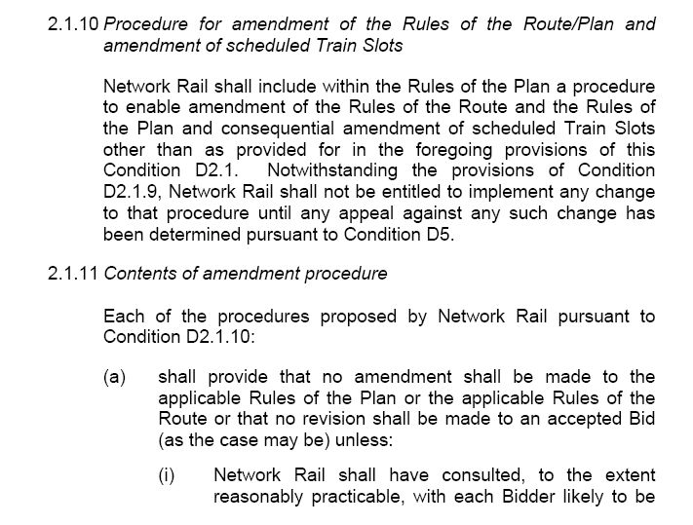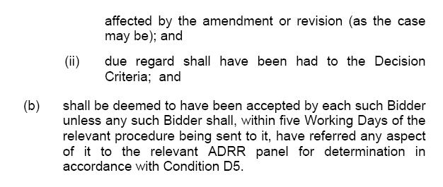

ANNEX “A”
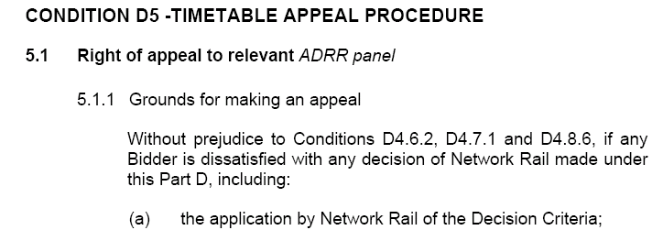
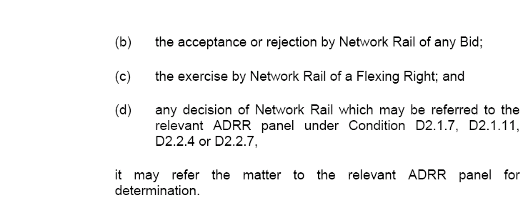
ANNEX “A”
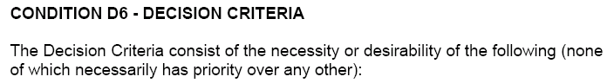
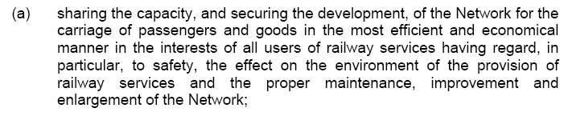
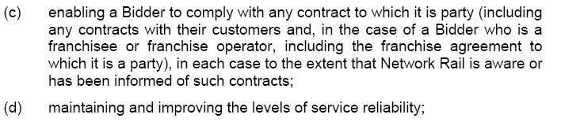
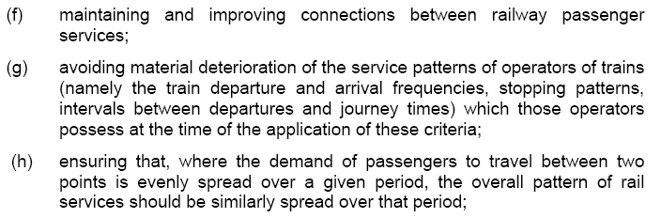
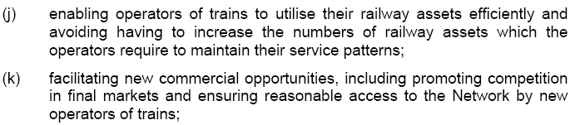
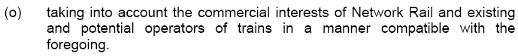
ANNEX “B”
Driver Training Options A to C – Information Only
Option “A”
This scenario was one in which Network Rail would continue with the already agreed possession plan, and still attempt to deliver the VHF Delivery date of December 2008. However due to the difficulties experienced with Rugby during the Christmas and New Year 2007 period, exacerbated by the significant de-scoping of the Trent Valley work during the recent Easter 2008 period, this Option was agreed throughout the Industry and Network Rail as being one that could not be delivered.

Option “B1”
This Option continued to support the launch of VHF in December 2008, but with revised and new engineering work proposals, some of them substantial. However there were no built in Contingency measures in the case of over-runs or un-attained intermediate completion targets. The expected target of December 2008 would only have a 60-70% probability. Again the Industry (TOC’s) decided that this had too much risk built into the programme, and as such this Option was rejected.

Option “B2” (latterly Option “B” – NAUM-30)
This Option continued to support the launch of VHF in December 2008, but with substantially revised, new and contingency (FIREWALL) possessions. The expected target of December 2008 would have a 80-90% probability of full implementation. Whilst the Industry (TOC’s) considered this, particularly in respect of the FIREWALL disruption, it became Network Rail’s preferred Option (thus becoming the full Option “B”). Network Rail proposed such possession plan changes in the form of NAUM-13, and following Industry consultation NAUM30. It is these possessions to which this dispute relates.

Option “C”
This Option supported a delayed launch of VHF until May 2009 with the revised and new possession proposals spread over a longer time period, and planned such that the disruption would be less onerous on the TOC’s. At the time of the proposal the Option had not been fully explored, despite Industry (TOC’s) agreement that it should be (West Coast Project Board). This situation remains the same at time of press.

ANNEX “C”
Network Rail
Network Access Unit
6th Floor North Wing
City Exchange
11 Albion Street
LEEDS

Tel: 085 32230

Susan Nichol,
TSP & ROU Liaison Manger,
Virgin Trains.

Wednesday 2nd April 2008

LNW ROTR Changes for WCRM Enhancements

Dear Susan,

Thank you for your response of the 20th March 2008 to Network Rail’s proposed engineering access alterations to the 2008 ROTR to deliver WCRM enhancements. With colleagues from WCRM project I have reviewed your comments, and can confirm Network Rail’s point of view or agreed alterations to the proposals.

LNW 2008 ROTR section 4 possessions to be amended:
101.7 Bletchley South Jn and Hanslope Jn, Thank you for your support for this proposal. Please could you confirm the timing of the ECS you seek to return to Euston.

101.10 to 15 Hillmorton Jn and Armitage Jn, Weekend period ‘D’.
In the decision letter, Network Rail has made some changes which accommodate other operator’s issues with these proposals.

I note that many of your comments are repeated throughout your response, and have taken the opportunity to respond only once to these comments in the next few paragraphs.

We note the comments in relation to the impact on your business, and the CRE for Virgin West Coast would welcome further discussion as to its nature and magnitude.

Network Rail acknowledges that a number of the additional possession requested are within the timescales for planning and achieving T12 upload of amended train services, however we consider them essential to the successful delivery of the infrastructure required to support the December 2008 timetable improvement.

Network Rail will be issuing a separate document that outlines which existing possessions are to be cancelled to support these alterations to the WCRM possession plan. If you consider that we have missed any clashing possession please do let me know.

Shortly Network Rail will be issuing amendments to the LNW (S) Confirmed Period Possession Plans from week 9, which will incorporate the Rules of the Route in the decision letter dated 2nd April.

Network Rail notes your comments in relation to application of the decision criteria, but considers them fairly applied in these circumstances.

The impacts upon driver training continue to be discussed and we would seek your on going input as regard how Network Rail might assist you in managing this situation.
ANNEX “C”

We have separately received your feedback on the WCRM delivery plan consultation document, published in accordance with. ORR’s provisional order. This document shows the integration between these possessions and the overall delivery plan.

1001.7 Norton Bridge North Jn and Crewe South Jn, I can confirm sufficient capacity is available for all services to travel over the fast lines only on Sundays between Norton Bridge and Crewe.

1001.9 to 11 Crewe North Jn and Acton Grange Jn, Your comments regarding Liverpool being the capital of culture are noted.

2001.1 &2 Weaver Jn and Ditton East , Your comments regarding Liverpool being the capital of culture are noted.

LNW 2008 ROTR section 7 possession to be amended to read:

Atherstone and Armitage Jn
Week 9
The timetable plan for services via the West Midlands on a normal ‘SX’ day during this blockade will be as per the agreed plan implemented on Tue 25th March.

Hillmorton Jn and Shilton
Week 12
I can confirm sufficient information is available from the WCRM project to enable the withdrawal of this proposed firewall possession.

Carnforth North Jn and Penrith
Weeks 15 to 18
In the decision letter these possessions have been re-dated to weeks 18 to 21. I can confirm that this possession prevent 1R21, 1A25 from running in the booked paths. Network Rail wishes to explore the option for the ECS moves.

Shilton and Colwich Jn
Week 22 to 24
Your comments regarding this possession are noted.

Crewe North Jn and Preston Brook Tunnel
Week 26
Network Rail understood that the event planned in week 26 in relation to the Capital of Culture had been re-dated.

Hanslope Jn and Hillmorton Jn (via Northampton)
Week 28
In the decision letter Network Rail has amended the times for this possession to read 1000 Sat to 0400 Mon, there is no perceived problem with the capacity of all trains via Weedon.

Hanslope Jn and Hillmorton Jn (via Northampton)
Week 34
In the decision letter Network Rail has amended the times for this possession to read 1000 Sat to 0400 Mon, there is no perceived problem with the capacity of all trains via Weedon.
ANNEX “C”

Kilsby North Jn and Shilton Jn
Week 35/36
I can confirm that entry has been amended in the decision document and now reads:
PPS Ref: P2008/1007054
Week 35 Friday 21st to Monday 24th November 2008

At/Between: Kilsby North and Shilton
Lines: All BLOCKED
and
At/Between: Daventry South Jn and Hillmorton Jn
Lines: Down and Up Northampton BLOCKED
and
At/Between: Rugby Trent Valley Jn and Coventry South Jn
Lines: Down and Up Coventry BLOCKED
Times: 2315 Fri 21/11 to 0530 Mon 24/11

Hillmorton Jn and Shilton/Brandon
Week 39/40
Your comments regarding disruption over Christmas and New Year are noted.

Denbigh Hall South Jn and Hanslope Jn
Week 40/41
Your comments regarding disruption over Christmas and New Year are noted.

If you require further information or if I can help further, please give me a call.

Matt Allen
Yours sincerely,
Matt Allen, Network Access Unit Manager.

ANNEX “D”


Mr. M. Allen,
NAU Manager, Network Rail
6th Floor North Wing
City Exchange
11 Albion Street
Leeds

09th April 2008

Ref. NAUM-30/RH/Res

cc. T. Skilton, Secretary ADRC
A. Raisbeck, ESM WCRM

Dear Matt

WCTL Response to NAUM-30 LNW ROTR 2008 Decision Document

With reference to the above Final Decision Proposal, received from Network Rail dated 2nd April 2008, (as proposed under section D2.1.10 of the Network Code and Section 3.5 of the National Rules of the Plan), WCTL formally responds with the following comments as required under section 3.5.4 of the National Rules of the Plan and Sections D2.1.11b & 5.1 of the Network Code.

In view of the disappointing number of significant possession proposals and amendments that continue to remain within this final Decision document, we hereby outline our objections to the possessions on an individual possession basis. This will allow (in view of the short ADRC dispute timescales) each possession to be considered and understood on its own merits, with clarity and importance. Furthermore, it should hopefully enable a quicker and more transparent analysis for the ADRC should any or all of the objections reach the hearing stage.

Some of the fundamental aspects under which WCTL dispute these proposals, are on the basis that, in view of some of the short timescales within which these are being proposed (in a number of cases Informed Traveller Timescales {T-12} will not be met) and the obvious impact most of them will have on our passengers and business, we consider that Decision Criteria has not been given the appropriate regard by Network Rail.

This in terms of the practical reasonableness of amending the working timetable still further in the time available, balancing the needs of the travelling public as well as the inability by Network Rail to have adequately assessed (within three days) many of the specific issues highlighted in our preliminary response including issues regarding Timetable evidence to allay concerns regarding capacity and meeting our Firm Rights (Best Achievable Access Rights), continuing clashes with work on other routes and so on.

ANNEX “D”

In terms of potentially clashing possessions, a separate document to support this response, is attached as Appendix “A” and hitherto replaces the individual requirement for entries relevant to each individual possession as illustrated within the NAUM-30 documentation. Indeed a number of comments completely contradict the possessions themselves, for example in Week 23, the ‘Comments’ narrative states West Coast services will terminate/start at Northampton from London, but how can this be when Milton Keynes is closed all weekend. Such inconsistencies all add to our concern that the possession planning process is not robust, and therefore imports risk into our operations and delivery.

Furthermore, and this relates to one of the most significant aspects regarding our stance with such possession proposals, is the effect on our Driver Training programme, both iteratively and in terms of final delivery. It has already been clearly stipulated by West Coast in our response to Network Rail’s WCRM Delivery Plan, that we do not accept Option B (to which most of these possessions relate), primarily because of our inability to safely and operationally deliver a Driver Training Programme, without severe detriment to the travelling public, in the timescales necessary for the introduction of the VHF Timetable in December 2008 or January 2009 respectively.

Therefore in consideration of the following:

a) WCTL formally responds to Network Rail with the following comments as required under section 3.5.4 of the National Rules of the Plan and Sections D2.1.11b & 5.1 of the Network Code;

b) WCTL submits this response under Network Code conditions D2.1.11b and D5.1 to the Disputes Secretary of the Access Disputes Timetable Panel for determination;

c) WCTL will formulate and submit (as directed under ADRR rules part A1.30, but amended by an e-mail dated 03/04/08) an individual response to the ADRC, outlining its position with regards to each contentious item;

WCTL hereby responds to Network Rail with the following concerns and objections. We shall nonetheless endeavour in the meantime, to resolve with Network Rail as many of the disputed items as possible,

Yours Sincerely

Robert Hodgkinson
Commercial Operations Manager
West Coast Trains Ltd.

ANNEX “D”

LNW 2008 ROTR section 4 possessions to be amended to read:
MD101 EUSTON TO ARMITAGE JN
101.10 Hillmorton Jn and Trent Valley Jn, Weekend period ‘D’ amended to read 1015 Sat to 0935 Sun All BLOCKED and weekend period ‘E’ amended to read 2210 Sat to 0945 Sun (Network Rail Request).
NOTE: Between Hillmorton Jn and Long Lawford, the Down Fast (between Hillmorton Jn and Rugby) and Down Coventry (between Rugby and Long Lawford) is available until 1700 Sat for nominated freight services only.
101.11 Trent Valley Jn and Nuneaton South Jn, Weekend period ‘D’ amended to read 1015 Sat to 0930 Sun All BLOCKED (Network Rail Request).
101.12 Nuneaton South Jn and Nuneaton North Jn, Weekend period ‘D’ amended to read 1015 Sat to 0930 Sun All BLOCKED (Network Rail Request).
101.13 Nuneaton North Jn and Tamworth Low Level, Weekend period ‘D’ amended to read 1000 Sat to 0930 Sun All BLOCKED (Network Rail Request).
101.14 Tamworth Low Level and Lichfield Trent Valley Jn, Weekend period ‘D’ amended to read 1000 Sat to 0930 Sun All BLOCKED (Network Rail Request).
101.15 Lichfield Trent Valley Jn and Armitage Jn, Weekend period ‘D’ amended to read 1000 Sat to 0930 Sun All BLOCKED (Network Rail Request).

WCTL disputes the above extended possessions at Rugby in periods D & E and Trent Valley in Period D2 because of:
- the overall and excessive impact to our business, both operationally and commercially;
- the possessions in Period D1 are not likely to be formally agreed and thus proposed, (following an expectation of dispute hearing{s} in May) within due T-12 timescales, thus being insufficient to provide robust & reliable information to passengers as well as being unable to open reservations;
- unreasonable application of Decision Criteria parts ‘(c), (d), (f), (g), (j); and
- the severe constraints that such proposals will put onto WCTL VHF Driver Training Programme, such that there would be considerable risk to the delivery of the December 2008 timetable; this also in conjunction with the unreasonable application of Decision Criteria parts (k), (o);

MD301 RUGBY TRENT VALLEY JN TO PENKRIDGE (VIA BIRMINGHAM)
301.1 Trent Valley Jn and Coventry South Jn, Weekend period ‘D’ amended to read 1730 Sat to 0500 Mon BLOCKED Electrical isolations Rugby to Coventry North to be lifted by 0450 Mon (Network Rail Request).

WCTL disputes the above extended possessions at Rugby in periods D & E and Trent Valley in Period D2 because of:
- the overall, and in Period D, excessive impact to our business, both operationally and commercially;
- the possessions in Period D1 are not likely to be formally agreed and thus proposed, (following an expectation of dispute hearing{s} in May) within due T-12 timescales, thus being insufficient to provide robust & reliable information to passengers as well as being unable to open reservations;
- unreasonable application of Decision Criteria parts ‘(c), (d), (f), (g), (j);
- the severe constraints that such proposals will put onto WCTL VHF Driver Training Programme, such that there would be considerable risk to the delivery of the December 2008 timetable; this also in conjunction with the unreasonable application of Decision Criteria parts (k), (o);

ANNEX “D”

NW1001 ARMITAGE JN TO PRESTON FYLDE JN
1001.9 Crewe North Jn and Winsford South Jn, Weekend period ‘D’ amended to read 0001 Sun to 0910 Sun BLOCKED until Sunday 13th July 2008 and 2300 Sat to 1025 Sun BLOCKED from Saturday 19th July 2008
1001.10 Winsford South Jn and Weaver Jn, Weekend period ‘D’ amended to read 0001 Sun to 0910 Sun BLOCKED until Sunday 13th July 2008 and 2300 Sat to 1025 Sun BLOCKED from Saturday 19th July 2008
1001.11 Weaver Jn and Acton Grange Jn, Weekend period ‘D’ amended to read 2345 Sat to 0900 Sun BLOCKED until Sunday 13th July 2008 and 2300 Sat to 1025 Sun BLOCKED from Saturday 19th July 2008

WCTL disputes the above extended possessions between Crewe - Acton Grange on Sunday Mornings in period D because of:
- the impact to our business, both operationally and commercially in conjunction with the additional Sunday morning requirements in association with the last bullet point set out below;
- unreasonable application of Decision Criteria parts ‘(c), (d), (f), (g), (j); and
- an expectation that in the Summer Period, any impact (to that already agreed) in providing services to/from Liverpool during the “City of Culture” celebrations/events, will not be seen to be popular and/or nationally productive.

NW2001 WEAVER JN TO LIVEPOOL LIME STREET
2001.1 Weaver Jn and Sutton Weaver GF, Weekend period ‘D’ amended to read 0001 Sun to 0945 Sun BLOCKED until Sunday 13th July 2008 and 2300 Sat to 1025 Sun BLOCKED from Saturday 19th July 2008
2001.2 Sutton Weaver GF and Ditton East Jn, Weekend period ‘D’ amended to read 0010 Sun to 0925 Sun BLOCKED until Sunday 13th July 2008 and 2300 Sat to 1025 Sun BLOCKED from Saturday 19th July 2008

WCTL disputes the above extended possessions between Weaver Jn and Liverpool on Sunday Mornings in period D because of:
- the impact to our business, both operationally and commercially in conjunction with the additional Sunday morning requirements in association with the last bullet point set out below;
- unreasonable application of Decision Criteria parts ‘(c), (d), (f), (g), (j); and
- an expectation that in the Summer Period, any impact (to that already agreed) in providing services to/from Liverpool during the “City of Culture” celebrations/events, will not be seen to be popular and/or nationally productive.

ANNEX “D”

Existing LNW 2008 ROTR section 7 possession to be amended to read:
PPS Ref: P2008/ 835272
Week 9 Saturday 24th to Thursday 29th May 2008

At/Between: Atherstone and Armitage Jn
Lines: All BLOCKED
Times: 0030 Sat to 0530 Thu
Work: Track & OLE in Preparation for signalling commissioning
Traffic Remarks: TRAINS TO BE DIVERTED VIA THE WEST MIDLANDS. ACCESS RUGELEY POWER STATION FROM THE HEDNESFORD DIRECTION ONLY.
WCTL disputes the additional possession on the Wednesday only on the Trent Valley in week 9 because of:
- the additional impact to our business (bearing in mind that originally a southern end of the Trent Valley blockade occurred until the Tuesday – as agreed previously but subject to Network Change compensation) both operationally and commercially;
- this additional day on the Trent Valley is not likely to be formally agreed and thus proposed, (following an expectation of dispute hearing{s} in early May) within due T-12 timescales, thus being insufficient to provide robust & reliable information to passengers as well as being unable to open reservations;
- unreasonable application of Decision Criteria parts ‘(c), (d), (f), (g), (h) (j);
- the National upheaval in terms of capacity implications of diverting services via the West Midlands for another working weekday – Although Network Rail have textually confirmed that sufficient capacity will be available on the weekdays as per the timetable plan subsequently operated on Tuesday 25th March 2008, we still do not have documentary timetable evidence that this is possible to deliver);
- the severe constraints that such a proposal will put onto WCTL VHF Driver Training Programme, such that there would be considerable risk to the delivery of the December 2008 timetable; this also in conjunction associated with the unreasonable application of Decision Criteria parts (k), (o);

LNW 2008 ROTR additional possession request for section 7:
PPS Ref: P2008/xxxxxx
Week 15 Saturday 5th to Sunday 6th July 2008
At/Between: Preston Fylde Jn and Lancaster South Jn
Lines: All BLOCKED
Times: 2100 Sat to 1300 Sun
Work: Line Speed Enhancements

Traffic Remarks: TRAINS TO START/TERMINATE AT PRESTON OR LANCASTER, RAIL REPLACEMENT ROAD SERVICE TO OPERATE.

WCTL disputes the above extended possession north of Preston in Week 15 because of:
- the overall impact to our business on Sunday morning, both operationally and commercially;
- the possession not expected to be proposed within due T-12 timescales, thus being insufficient to provide robust & reliable information to passengers as well as being unable to open reservations;
- unreasonable application of Decision Criteria parts ‘(c), (d), (f), (g), (j);

ANNEX “D”

LNW 2008 ROTR additional possession request for section 7:
PPS Ref: P2008/xxxxxx
Week 16 Saturday 12th to Sunday 13th July 2008

At/Between: Preston Fylde Jn and Lancaster South Jn
Lines: All BLOCKED
Times: 2100 Sat to 1300 Sun
Work: Line Speed Enhancements
Traffic Remarks: TRAINS TO START/TERMINATE AT PRESTON OR LANCASTER, RAIL REPLACEMENT ROAD SERVICE TO OPERATE.
WCTL disputes the above extended possession north of Preston in Week 16 because of:
- the overall impact to our business on Sunday morning, both operationally and commercially;
- the possession not expected to be proposed within due T-12 timescales, thus being insufficient to provide robust & reliable information to passengers as well as being unable to open reservations;
- unreasonable application of Decision Criteria parts ‘(c), (d), (f), (g), (j); and

LNW 2008 ROTR additional possession request for section 7:
PPS Ref: P2008/xxxxxx
Week 17 Saturday 19th to Sunday 20th July 2008

At/Between: Preston Fylde Jn and Lancaster South Jn
Lines: All BLOCKED
Times: 2100 Sat to 1300 Sun
Work: Line Speed Enhancements

Traffic Remarks: TRAINS TO START/TERMINATE AT PRESTON OR LANCASTER, RAIL REPLACEMENT ROAD SERVICE TO OPERATE.

WCTL disputes the above extended possession north of Preston in Week 17 because of:
- the overall impact to our business on Sunday morning, both operationally and commercially;
- unreasonable application of Decision Criteria parts ‘(c), (d), (f), (g), (j); and

LNW 2008 ROTR additional possession request for section 7:
PPS Ref: P2008/xxxxxx
Week 17 Sunday 20th to Monday 21st July 2008
At/Between: Crewe North Jn and Cheadle Hulme
Lines: Down and Up Wilmslow BLOCKED
Times: 0030 Sun to 0400 Mon
Work: Line Speed Enhancements

Traffic Remarks: TRAINS TO BE DIVERTED VIA STOKE ON TRENT AND MACCLESFIELD OR VIA CHAT MOSS AND WCML. NORTHERN RAIL SERVICES TO DIVERT VIA STYAL AND START/TERMINATE AT WILMSLOW. RAIL REPLACEMENT ROAD SERVICES TO OPERATE. A ROUTE TO BE MAINTAINED FROM CREWE TO NORTHWICH VIA THE MANCHESTER INDENPENTS AND SANDBACH.

WCTL disputes the above additional possession between Crewe and Cheadle in week 17 because of:
- the overall impact to our business, both operationally and commercially;
- unreasonable application of Decision Criteria parts ‘(c), (d), (f), (g), (j);

ANNEX “D”

LNW 2008 ROTR additional possession request for section 7:
PPS Ref: P2008/xxxxxx
Week 18 Saturday 26th to Sunday 27th July 2008

At/Between: Preston Fylde Jn and Lancaster South Jn
Lines: All BLOCKED
Times: 2100 Sat to 1300 Sun
Work: Line Speed Enhancements

Traffic Remarks: TRAINS TO START/TERMINATE AT PRESTON OR LANCASTER, RAIL REPLACEMENT ROAD SERVICE TO OPERATE.

WCTL disputes the above extended possession north of Preston in Week 18 because of:
- the overall impact to our business on Sunday morning, both operationally and commercially;
- unreasonable application of Decision Criteria parts ‘(c), (d), (f), (g), (j); and

LNW 2008 ROTR additional possession request for section 7:
PPS Ref: P2008/xxxxxx
Week 18 Saturday 26th to Monday 28th July 2008

At/Between: Oxenholme and Hardendale
Lines: All BLOCKED
Times: 0415 Sat to 2000 Sat
and
At/Between: Oxenholme and Penrith
Lines: All BLOCKED
Times: 2000 Sat to 2310 Sat
and
At/Between: Carnforth North Jn and Penrith
Lines: All BLOCKED
Times: 2310 Sat to 0400 Mon
Work: Line Speed Enhancements

Traffic Remarks: TRAINS TO BE DIVERTED VIA SETTLE AND APPLEBY. TRAINS TO START/TERMINATE AT LANCASTER OR PENRITH, RAIL REPLACEMENT ROAD SERVICE TO OPERATE. 2000 SAT TO 0400 MON NO ACCESS HARDENDALE AND HARRISON SIDINGS. 2310 SAT TO 0400 MON AT OXENHOLME NO ACCESS WINDERMERE. FREIGHT TO BE RE-TIMED. SUN/MON SLEEPER TO BE DIVERTED VIA ECML

WCTL disputes the above additional possession north of Carnforth in week 18 (and in direct conjunction with the above Preston to Lancaster possession) because of:
- the overall impact to our business, both operationally and commercially;
- unreasonable application of Decision Criteria parts ‘(c), (d), (f), (g), (j); and
- Confirmation from Network Rail that we will not be able to run key morning services from Carlisle on Monday [1R21 & 1A25] as well as the requirement for appropriate paths to be made available to move their applicable ECS movements.

ANNEX “D”

LNW 2008 ROTR additional possession request for section 7:
PPS Ref: P2008/xxxxxx
Week 18 Sunday 27th to Monday 28th July 2008

At/Between: Crewe North Jn and Cheadle Hulme
Lines: Down and Up Wilmslow BLOCKED
Times: 0030 Sun to 0400 Mon
Work: Line Speed Enhancements

Traffic Remarks: TRAINS TO BE DIVERTED VIA STOKE ON TRENT AND MACCLESFIELD OR VIA CHAT MOSS AND WCML. NORTHERN RAIL SERVICES TO DIVERT VIA STYAL AND START/TERMINATE AT WILMSLOW. RAIL REPLACEMENT ROAD SERVICES TO OPERATE. A ROUTE TO BE MAINTAINED FROM CREWE TO NORTHWICH VIA THE MANCHESTER INDENPENTS AND SANDBACH.

WCTL disputes the above additional possession between Crewe and Cheadle in week 18 because of:
- the overall impact to our business, both operationally and commercially;
- unreasonable application of Decision Criteria parts ‘(c), (d), (f), (g), (j);

LNW 2008 ROTR additional possession request for section 7:
PPS Ref: P2008/xxxxxx
Week 19 Saturday 2nd to Sunday 3rd August 2008

At/Between: Preston Fylde Jn and Lancaster South Jn
Lines: All BLOCKED
Times: 2100 Sat to 1300 Sun
Work: Line Speed Enhancements

Traffic Remarks: TRAINS TO START/TERMINATE AT PRESTON OR LANCASTER, RAIL REPLACEMENT ROAD SERVICE TO OPERATE.

WCTL disputes the above extended possession north of Preston in Week 19 because of:
- the overall impact to our business on Sunday morning, both operationally and commercially;
- unreasonable application of Decision Criteria parts ‘(c), (d), (f), (g), (j); and

ANNEX “D”

LNW 2008 ROTR additional possession request for section 7:
PPS Ref: P2008/xxxxxx
Week 19 Saturday 2nd to Monday 4th August 2008

At/Between: Oxenholme and Hardendale
Lines: All BLOCKED
Times: 0415 Sat to 2000 Sat
and
At/Between: Oxenholme and Penrith
Lines: All BLOCKED
Times: 2000 Sat to 2310 Sat
and
At/Between: Carnforth North Jn and Penrith
Lines: All BLOCKED
Times: 2310 Sat to 0400 Mon
Work: Line Speed Enhancements

Traffic Remarks: TRAINS TO BE DIVERTED VIA SETTLE AND APPLEBY. TRAINS TO START/TERMINATE AT LANCASTER OR PENRITH, RAIL REPLACEMENT ROAD SERVICE TO OPERATE. 2000 SAT TO 0400 MON NO ACCESS HARDENDALE AND HARRISON SIDINGS. 2310 SAT TO 0400 MON AT OXENHOLME NO ACCESS WINDERMERE. FREIGHT TO BE RE-TIMED. SUN/MON SLEEPER TO BE DIVERTED VIA ECML

WCTL disputes the above additional possession north of Carnforth in week 19 (and in direct conjunction with the above Preston to Lancaster possession) because of:
- the overall impact to our business, both operationally and commercially;
- unreasonable application of Decision Criteria parts ‘(c), (d), (f), (g), (j); and
- Confirmation from Network Rail that we will not be able to run key morning services from Carlisle on Monday [1R21 & 1A25] as well as the requirement for appropriate paths to be made available to move their applicable ECS movements.

ANNEX “D”

LNW 2008 ROTR additional possession request for section 7:
PPS Ref: P2008/xxxxxx
Week 20 Saturday 9th to Monday 11th August 2008

At/Between: Oxenholme and Hardendale
Lines: All BLOCKED
Times: 0415 Sat to 2000 Sat
and
At/Between: Oxenholme and Penrith
Lines: All BLOCKED
Times: 2000 Sat to 2310 Sat
and
At/Between: Carnforth North Jn and Penrith
Lines: All BLOCKED
Times: 2310 Sat to 0400 Mon
Work: Line Speed Enhancements

Traffic Remarks: TRAINS TO BE DIVERTED VIA SETTLE AND APPLEBY. TRAINS TO START/TERMINATE AT LANCASTER OR PENRITH, RAIL REPLACEMENT ROAD SERVICE TO OPERATE. 2000 SAT TO 0400 MON NO ACCESS HARDENDALE AND HARRISON SIDINGS. 2310 SAT TO 0400 MON AT OXENHOLME NO ACCESS WINDERMERE. FREIGHT TO BE RE-TIMED. SUN/MON SLEEPER TO BE DIVERTED VIA ECML

WCTL disputes the above additional possession north of Carnforth in week 20 because of:
- the overall impact to our business, both operationally and commercially;
- unreasonable application of Decision Criteria parts ‘(c), (d), (f), (g), (j); and
- Confirmation from Network Rail that we will not be able to run key morning services from Carlisle on Monday [1R21 & 1A25] as well as the requirement for appropriate paths to be made available to move their applicable ECS movements.

ANNEX “D”

Existing LNW 2008 ROTR additional possession request for section 7:
PPS Ref: P2008/869953
Week 21 Friday 15th to Monday 18th August 2008

At/Between: Denbigh Hall North Jn and Hanslope Jn
Lines: Down and Up Slow BLOCKED
Times: 2200 Fri to 0930 Sat
and
At/Between: Denbigh Hall North Jn and Hanslope Jn
Lines: All BLOCKED
Times: 0930 Sat to 0300 Mon
Work: Install S&C

Traffic Remarks:
2200 FRI TO 0930 SAT TRAINS TO BE TRAVEL OVER FAST LINES. 2200 FRI TO 0300 MON NO ACCESS MILTON KEYNES CENTRAL BAY PLATFORM AND WOLVERTON RAILCARE SIDINGS. 0930 SAT TO 0300 MON TRAINS TO START/TERMINATE FROM THE SOUTH AT BLETCHLEY. TRAINS TO/FROM THE NORTH TO START/TERMINATE AT COVENTRY OR BIRMINGHAM INTERNATIONAL. TRAINS TO BE DIVERTED VIA ACTON WELLS, ACTON MAIN LINE, EALING BROADWAY, GREENFORD, SOUTH RUISLIP, CHILTERNS, BANBURY AND LEAMINGTON OR NORTH LONDON LINE, KINGS CROSS INCLINE AND ECML.

Whilst WCTL accept the Friday Night/ Saturday morning SL proposal, it disputes the Saturday & Sunday possession at Milton Keynes in week 21 because of:
- the overall and excessive impact to our business, both operationally and commercially;
- unreasonable application of Decision Criteria parts ‘(c), (d), (f), (g), (j); and
- the severe constraints that such a proposal will put onto WCTL VHF Driver Training Programme, such that there would be considerable risk to the delivery of the December 2008 timetable; this also in conjunction associated with the unreasonable application of Decision Criteria parts (k), (o);

ANNEX “D”

LNW 2008 ROTR additional possession request for section 7:
PPS Ref: P2008/xxxxxx
Week 21 Saturday 16th to Monday 18th August 2008
At/Between: Oxenholme and Hardendale
Lines: All BLOCKED
Times: 0415 Sat to 2000 Sat
and
At/Between: Oxenholme and Penrith
Lines: All BLOCKED
Times: 2000 Sat to 2310 Sat
and
At/Between: Carnforth North Jn and Penrith
Lines: All BLOCKED
Times: 2310 Sat to 0400 Mon
Work: Line Speed Enhancements

Traffic Remarks: TRAINS TO BE DIVERTED VIA SETTLE AND APPLEBY. TRAINS TO START/TERMINATE AT LANCASTER OR PENRITH, RAIL REPLACEMENT ROAD SERVICE TO OPERATE. 2000 SAT TO 0400 MON NO ACCESS HARDENDALE AND HARRISON SIDINGS. 2310 SAT TO 0400 MON AT OXENHOLME NO ACCESS WINDERMERE. FREIGHT TO BE RE-TIMED. SUN/MON SLEEPER TO BE DIVERTED VIA ECML
WCTL disputes the above additional possession north of Carnforth in week 21 because of:
- the overall impact to our business, both operationally and commercially;
- unreasonable application of Decision Criteria parts ‘(c), (d), (f), (g), (j); and
- Confirmation from Network Rail that we will not be able to run key morning services from Carlisle on Monday [1R21 & 1A25] as well as the requirement for appropriate paths to be made available to move their applicable ECS movements.

ANNEX “D”

Existing LNW 2008 ROTR additional possession request for section 7:
PPS Ref: P2008/836253
Week 22 Saturday 23rd to Wednesday 27th August 2008

At/Between: Hillmorton Jn and Shilton
Lines: All BLOCKED
and
At/Between: Rugby Trent Valley Jn and Coventry South Jn
Lines: Down and Up Coventry BLOCKED
Times: 0130 Sat to 0500 Wed
Work: Preparation for signalling commissioning

Traffic Remarks: 0130 SAT TO 1000 SAT TRAINS FROM THE SOUTH TO START/TERMINATE AT NORTHAMPTON, BETWEEN 1000 SAT TO 0100 SUN AT BLETCHLEY, 0830 SUN TO 1200 SUN AT WATFORD JN, FROM 1200 SUN TO 0300 TUE AT HEMEL HEMPSTEAD, FROM 0300 TUE TO 0500 WED AT NORTHAMPTON. 0300 SAT TO 0500 WED TRAINS TO/FROM THE NORTH TO START/TERMINATE AT COVENTRY OR BIRMINGHAM INTERNATIONAL. 0300 SAT TO 1000 SAT AND 0300 TUE TO 0500 WED ACCESS NORTHAMPTON STATION, NORTHAMPTON UP YARD, KINGS HEATH TMD, DAVENTRY IRFT FROM THE SOUTH ONLY. 0300 SAT TO 0300 TUE NO ACCESS NORTHAMPTON STATION, NORTHAMPTON UP SIDE YARD, KINGS HEATH TMD AND DAVENTRY IRFT. 0300 SAT TO 0500 WED TRAINS TO BE DIVERTED VIA ACTON WELLS, ACTON MAIN LINE, EALING BROADWAY, GREENFORD, SOUTH RUISLIP, CHILTERNS, BANBURY AND LEAMINGTON OR NORTH LONDON LINE, KINGS CROSS INCLINE AND ECML.

WCTL disputes the above extended possession (Tuesday only) at Rugby in week 22 because of:
- the additional impact to our business, both operationally and commercially particularly as it involves a weekday;
- unreasonable application of Decision Criteria parts ‘(c), (d), (f), (g), (h), (j); and
- the severe constraints that such proposals will put onto WCTL VHF Driver Training Programme, such that there would be considerable risk to the delivery of the December 2008 timetable; this also in conjunction associated with the unreasonable application of Decision Criteria parts (k), (o);

ANNEX “D”

Existing LNW 2008 ROTR additional possession request for section 7:
PPS Ref: P2008/1006111
Week 22 to 24 Saturday 23rd August to Monday 8th September 2008

At/Between: Shilton and Colwich Jn
Lines: All BLOCKED
and
At/Between: Hawksbury Lane SB and Nuneaton South Jn
Lines: All BLOCKED
Times: 0030 Sat 23/8 to 0530 Mon 8/9
and
At/Between: Croft Sidings and Abbey Jn
Lines: Down and Up Hinckley BLOCKED
and
At/Between: Nuneaton North Jn and Daw Mill
Lines: All BLOCKED
Times: 0030 Sat 23/8 to 0530 Tue 26/8
Work: Signalling Commissioning (Nuneaton Interlockings – North, South, East, West and Atherstone).

Traffic Remarks: 0030 SAT 23/8 TO 0530 MON 8/9
TRAINS TO BE DIVERTED VIA WEST MIDLANDS. RAIL REPLACEMENT ROAD SERVICE TO OPERATE BETWEEN COVENTRY AND NUNEATON. ACCESS AVAILABLE BEDWORTH CALOR GAS SIDING FROM THE COVENTRY DIRECTION ONLY.
0030 SAT 23/8 TO 0530 TUE 26/8
TRAINS TO BE DIVERTED VIA TRENT, BURTON ON TRENT AND TAMWORTH. NO ACESS NUNEATON STATION. ACCESS DAW MILL COLLIERY FROM THE WHITACRE JN DIRECTION ONLY. BIRMINGHAM TO PETERBOROUGH SERVICES TO START/TERMINATE AT LEICESTER, RAIL REPLACEMENT ROAD SERVICE TO OPERATE BETWEEN BIRMINGHAM AND LEICESTER AND COVENTRY AND NUNEATON.
0530 TUE 26/8 TO 0530 MON 8/9
AT NUNEATON ACCESS AVAILABLE BETWEEN ARLEY AND HINCKLEY VIA PLATFORMS 6 & 7.

WCTL disputes the above extended possession on the Trent Valley between Weeks {22} 23 to 24 because of:
- the overall and excessive impact to our business, both operationally and commercially particularly as it includes weekdays;
- unreasonable application of Decision Criteria parts ‘(c), (d), (f), (g), (h), (j);
- the severe constraints that such proposals will put onto WCTL VHF Driver Training Programme, such that there would be considerable risk to the delivery of the December 2008 timetable; this also in conjunction associated with the unreasonable application of Decision Criteria parts (k), (o);
- the National upheaval in terms of capacity implications of diverting services via the West Midlands for two weeks – WCTL still wishes to see clarification that the timetable plan subsequently operated on Tuesday 25th March 2008, can be delivered each day during this blockade taking cognisance of the fact that Rugby (subject to dispute) is also blocked over the three weekends, and in conjunction with other engineering works that maybe ensuing elsewhere on the Network,
- NOTE: WCTL has already agreed to the period originally proposed (subject to compensation matters being resolved, but DOES NOT AGREE to the second week ie. from 05.30 Mon 1st to 05.30 Mon 8th September inc.

ANNEX “D”

LNW 2008 ROTR additional possession request for section 7:
PPS Ref: P2008/xxxxxx
Week 25 Sunday 14th to Monday 15th September 2008
At/Between: Colwich Jn and Macclesfield
Lines: All BLOCKED
Times: 0005 Sun to 0530 Mon
Work: Line Speed Enhancements
Traffic Remarks: TRAINS TO BE DIVERTED VIA CREWE AND WILMSLOW. NORTHERN RAIL SERVICES TO SHUTTLE BETWEEN MACCLESFIELD AND MANCHESTER. EAST MIDLANDS TRAIN SERVICES TO START/TERMINATE AT UTTOXETER. NO ACCESS MARCROFT ENGINEERING SIDINGS, STOKE ON TRENT STATION, LNW YARD AND LONGPORT FREIGHT DEPOT. RAIL REPLACEMENT ROAD SERVICES TO OPERATE BETWEEN STAFFORD, STOKE AND MACCLESFIELD & UTTOXETER, STOKE & CREWE.

WCTL disputes the above extended possession on the Potteries in week 25 because of:
- the overall impact to our business, both operationally and commercially;
- unreasonable application of Decision Criteria parts ‘(c), (d), (f), (g), (j);

LNW 2008 ROTR additional possession request for section 7:
PPS Ref: P2008/xxxxxx
Week 26 Saturday 20th to Monday 22nd September 2008

At/Between: Crewe North Jn and Preston Brook Tunnel
Lines: All BLOCKED
and
At/Between: Weaver Jn and Ditton East Jn
Lines: All BLOCKED
Times: 0020 Sat to 0215 Mon

Traffic Remarks: 0020 SAT TO 1200 SAT TRAINS TO BE DIVERTED VIA WILMSLOW, STOCKPORT, MANCHESTER AND CHAT MOSS. 1200 SAT TO 0215 MON TRAINS TIMETABLED VIA MANCHESTER. FRI/SAT SLEEPERS TO DIVERT VIA ECML.

WCTL disputes the above additional possession between Crewe and Liverpool / Preston in week 26 because of:
- the overall impact to our business, both operationally and commercially;
- unreasonable application of Decision Criteria parts ‘(c), (d), (f), (g), (j);
- a requirement during this weekend to maintain a through electrified route to Liverpool at all times, thus providing essential service provision for the Liverpool “City of Culture” celebrations & closing event as provided for in the ROTR and December 2006 Virgin West Coast / Network Rail Settlement Agreement.

ANNEX “D”

LNW 2008 ROTR additional possession request for section 7:
PPS Ref: P2008/xxxxxx
Week 26 Sunday 21st to Monday 22nd September 2008
At/Between: Colwich Jn and Macclesfield
Lines: All BLOCKED
Times: 0005 Sun to 0530 Mon
Work: Line Speed Enhancements

Traffic Remarks: TRAINS TO BE DIVERTED VIA CREWE AND WILMSLOW. NORTHERN RAIL SERVICES TO SHUTTLE BETWEEN MACCLESFIELD AND MANCHESTER. EAST MIDLANDS TRAIN SERVICES TO START/TERMINATE AT UTTOXETER. NO ACCESS MARCROFT ENGINEERING SIDINGS, STOKE ON TRENT STATION, LNW YARD AND LONGPORT FREIGHT DEPOT. RAIL REPLACEMENT ROAD SERVICES TO OPERATE BETWEEN STAFFORD, STOKE AND MACCLESFIELD & UTTOXETER, STOKE & CREWE.
WCTL disputes the above extended possession on the Potteries in week 26 because of:
- the overall impact to our business, both operationally and commercially;
- unreasonable application of Decision Criteria parts ‘(c), (d), (f), (g), (j);

LNW 2008 ROTR additional possession request for section 7:
PPS Ref: P2008/xxxxxx
Week 27 Sunday 28th to Monday 29th September 2008
At/Between: Colwich Jn and Macclesfield
Lines: All BLOCKED
Times: 0005 Sun to 0530 Mon
Work: Line Speed Enhancements

Traffic Remarks: TRAINS TO BE DIVERTED VIA CREWE AND WILMSLOW. NORTHERN RAIL SERVICES TO SHUTTLE BETWEEN MACCLESFIELD AND MANCHESTER. EAST MIDLANDS TRAIN SERVICES TO START/TERMINATE AT UTTOXETER. NO ACCESS MARCROFT ENGINEERING SIDINGS, STOKE ON TRENT STATION, LNW YARD AND LONGPORT FREIGHT DEPOT. RAIL REPLACEMENT ROAD SERVICES TO OPERATE BETWEEN STAFFORD, STOKE AND MACCLESFIELD AND UTTOXETER, STOKE AND CREWE.

WCTL disputes the above extended possession on the Potteries in week 27 because of:
- the overall impact to our business, both operationally and commercially;
- unreasonable application of Decision Criteria parts ‘(c), (d), (f), (g), (j);

ANNEX “D”

LNW 2008 ROTR additional possession request for section 7:
PPS Ref: P2008/xxxxxx
Week 28 Sunday 5th to Monday 6th October 2008
At/Between: Colwich Jn and Macclesfield
Lines: All BLOCKED
Times: 0005 Sun to 0530 Mon
Work: Line Speed Enhancements

Traffic Remarks: TRAINS TO BE DIVERTED VIA CREWE AND WILMSLOW. NORTHERN RAIL SERVICES TO SHUTTLE BETWEEN MACCLESFIELD AND MANCHESTER. EAST MIDLANDS TRAIN SERVICES TO START/TERMINATE AT UTTOXETER. NO ACCESS MARCROFT ENGINEERING SIDINGS, STOKE ON TRENT STATION, LNW YARD AND LONGPORT FREIGHT DEPOT. RAIL REPLACEMENT ROAD SERVICES TO OPERATE BETWEEN STAFFORD, STOKE AND MACCLESFIELD AND UTTOXETER, STOKE AND CREWE.

WCTL dispute the above extended possession on the Potteries in Wk 28 because of:
- the overall impact to our business, both operationally and commercially;
- unreasonable application of Decision Criteria parts ‘(c), (d), (f), (g), (j);

ANNEX “D”

LNW 2008 ROTR additional possession request for section 7:
PPS Ref: P2008/xxxxxx
Week 28 Saturday 4th to Monday 6th October 2008
At/Between: Hanslope Jn and Daventry North Jn
Lines: All BLOCKED
Times: 1000 Sat to 1900 Sat
and
At/Between: Hanslope Jn and Hillmorton Jn (via Northampton)
Lines: All BLOCKED
Times: 1900 Sat to 2320 Sat
and
At/Between: Hanslope Jn (inc) and Hillmorton Jn (via Northampton)
Lines: Down and Up Slow/Northampton BLOCKED
and
At/Between: Hanslope Jn (inc) and Blisworth
Lines: Down and Up Fast/Main BLOCKED
Times: 2320 Sat to 0915 Sun
and
At/Between: Hanslope Jn and Hillmorton Jn (via Northampton)
Lines: All BLOCKED
Times: 0915 Sun to 2100 Sun
and
At/Between: Hanslope Jn and Daventry North Jn
Lines: All BLOCKED
Times: 2100 Sun to 0400 Mon
Work: Signal installation, testing and pre-commissioning

Traffic Remarks: 1000 SAT TO 2320 SAT AND 0915 SUN TO 0400 MON TRAINS TO BE DIVERTED VIA WEEDON. 1000 SAT TO 0400 MON TRAINS TO START/TERMINATE AT MILTON KEYNES, RAIL REPLACEMENT ROAD SERVICE TO OPERATE. NORTHAMPTON TO BIRMINGHAM SERVICES TO OPERATE BETWEEN COVENTRY AND BIRMINGHAM ONLY ?????, RAIL REPLACEMENT ROAD SERVICE TO OPERATE. NO ACCESS NORTHAMPTON STATION, NORTHAMPTON RIVERSIDE SIDINGS, KINGS HEATH DEPOT AND NORTHAMPTON YARD.
1000 SAT TO 1900 SAT AND SUN 2100 SUN TO 0400 MON ACCESS DAVENTRY IRFT FROM THE RUGBY DIRECTION ONLY.
1900 SAT TO 2100 SUN
NO ACCESS DAVENTRY IRFT.

WCTL disputes the above additional possessions at Rugby and Northampton in week 28 because of:
- the overall and potentially excessive impact to our business, both operationally and commercially; but in particular we seek a requirement to understand the timetable and capacity affect on our business of diverting, (particularly on the Saturday morning), all traffic including Freight via the Old Lines (Weedon); Although Network Rail have informed us textually that WCTL will be able to operate a full service during this period, we still have not seen a timetable to support such statement;
- unreasonable application of Decision Criteria parts ‘(c), (d), (f), (g), (h), (j);
- the comments (as above) highlight that all services term / start at Milton Keynes with buses forward to Birningham international – Is this correct as the lines are open via Weedon all weekend including Rugby (exc Sat night) ????
- the severe constraints that such a proposal will put onto WCTL VHF Driver Training Programme, such that there would be considerable risk to the delivery of the December 2008 timetable; this also in conjunction associated with the unreasonable application of Decision Criteria parts (k), (o);

ANNEX “D”

LNW 2008 ROTR additional possession request for section 7:
PPS Ref: P2008/xxxxxx
Week 31 Saturday 25th to Tuesday 28th October 2008

At/Between: Rugby Trent Valley Jn and Atherstone
Lines: All BLOCKED
and
At/Between: Hawkesbury Lane
Lines: All BLOCKED
and
At/Between: Croft to Daw Mill
Lines: All BLOCKED
Times: 0030 Sat to 0530 Tue
Work: Nuneaton stage 2 commissioning Firewall possessions

Traffic Remarks: TRAINS TO BE DIVERTED VIA THE WEST MIDLANDS. TRAINS TO BE DIVERTED VIA TRENT, BURTON ON TRENT AND TAMWORTH. NO ACESS NUNEATON STATION. ACCESS DAW MILL COLLIERY FROM THE WHITACRE JN DIRECTION ONLY. BIRMINGHAM TO PETERBOROUGH SERVICES TO START/TERMINATE AT LEICESTER, RAIL REPLACEMENT ROAD SERVICE TO OPERATE BETWEEN BIRMINGHAM AND LEICESTER AND COVENTRY AND NUNEATON.

WCTL disputes the above FIREWALL possession on the Trent Valley in Week 31 because of:
- the potential additional impact to our business, both operationally and commercially particularly as it includes a weekday;
- unreasonable application of Decision Criteria parts ‘(c), (d), (f), (g), (h), (j);
- the National upheaval in terms of capacity implications of diverting services via the West Midlands on this weekend as well as one additional weekday – WCTL still wishes to see clarification that the timetable plan subsequently operated on Tuesday 25th March 2008, can be delivered during this blockade;
- the severe constraints that such proposals will put onto WCTL VHF Driver Training Programme, such that there would be considerable risk to the delivery of the December 2008 timetable; this also in conjunction associated with the unreasonable application of Decision Criteria parts (k), (o);

ANNEX “D”

LNW 2008 ROTR additional possession request for section 7:
PPS Ref: P2008/xxxxxx
Week 34 Saturday 15th to Monday 17th November 2008
At/Between: Hanslope Jn and Daventry North Jn
Lines: All BLOCKED
Times: 1000 Sat to 1900 Sat
and
At/Between: Hanslope Jn and Hillmorton Jn (via Northampton)
Lines: All BLOCKED
Times: 1900 Sat to 2320 Sat
and
At/Between: Hanslope Jn (inc) and Hillmorton Jn (via Northampton)
Lines: Down and Up Slow/Northampton BLOCKED
and
At/Between: Hanslope Jn (inc) and Blisworth
Lines: Down and Up Fast/Main BLOCKED
Times: 2320 Sat to 0915 Sun
and
At/Between: Hanslope Jn and Hillmorton Jn (via Northampton)
Lines: All BLOCKED
Times: 0915 Sun to 2100 Sun
and
At/Between: Hanslope Jn and Daventry North Jn
Lines: All BLOCKED
Times: 2100 Sun to 0400 Mon
Work: Signal commission and re-control

Traffic Remarks: 1000 SAT TO 2320 SAT AND 0915 SUN TO 0400 MON TRAINS TO BE DIVERTED VIA WEEDON. 1000 SAT TO 0400 MON TRAINS TO START/TERMINATE AT MILTON KEYNES, RAIL REPLACEMENT ROAD SERVICE TO OPERATE. NORTHAMPTON TO BIRMINGHAM SERVICES TO OPERATE BETWEEN COVENTRY AND BIRMINGHAM ONLY, RAIL REPLACEMENT ROAD SERVICE TO OPERATE. NO ACCESS NORTHAMPTON STATION, NORTHAMPTON RIVERSIDE SIDINGS, KINGS HEATH DEPOT AND NORTHAMPTON YARD.
1000 SAT TO 1900 SAT AND SUN 2100 SUN TO 0400 MON ACCESS DAVENTRY IRFT FROM THE RUGBY DIRECTION ONLY.
1900 SAT TO 2100 SUN
NO ACCESS DAVENTRY IRFT.

WCTL disputes the above additional possessions at Rugby and Northampton in week 34 because of:
- the overall and potentially excessive impact to our business, both operationally and commercially; but in particular we seek a requirement to understand the timetable and capacity affect on our business of diverting, (particularly on the Saturday morning), all traffic including Freight via the Old Lines (Weedon); Although Network Rail have informed us textually that WCTL will be able to operate a full service during this period, we still have not seen a timetable to support such statement;
- unreasonable application of Decision Criteria parts ‘(c), (d), (f), (g), (h), (j);
- the comments (as above) highlight that all services term / start at Milton Keynes with buses forward to Birningham international – Is this correct as the lines are open via Weedon all weekend and via Rugby on the Saturday (Sat night / and all day Sunday Rugby is closed – NAM-346 refers) ????
- the severe constraints that such a proposal will put onto WCTL VHF Driver Training Programme, such that there would be considerable risk to the delivery of the December 2008 timetable; this also in conjunction associated with the unreasonable application of Decision Criteria parts (k), (o);

ANNEX “D”

LNW 2008 ROTR additional possession request for section 7:

PPS Ref: P2008/xxxxxx
Week 37 Saturday 6th to Sunday 7th December 2008

At/Between: Hillmorton Jn and Shilton
Lines: All BLOCKED
and
At/Between: Trent Valley Jn and Brandon
Lines: Down and Up Coventry BLOCKED
Times: 1030 Sat to 2100 Sun
Work: Contingency for stage J signal commissioning

Traffic Remarks: TRAINS TO START/TERMINATE FROM THE SOUTH AT NORTHAMPTON. TRAINS TO/FROM THE NORTH TO START/TERMINATE AT COVENTRY OR BIRMINGHAM INTERNATIONAL. RAIL REPLACEMENT ROAD SERVICE TO OPERATE. TRAINS TO BE DIVERTED VIA ACTON WELLS, ACTON MAIN LINE, EALING BROADWAY, GREENFORD, SOUTH RUISLIP, CHILTERNS, BANBURY AND LEAMINGTON OR NORTH LONDON LINE, KINGS CROSS INCLINE AND ECML.

WCTL disputes the above additional possession at Rugby and on the Trent Valley in week 37 because of:

- the overall and excessive impact to our business, both operationally and commercially;
- unreasonable application of Decision Criteria parts ‘(c), (d), (f), (g), (j);

ANNEX “D”

LNW 2009 ROTR additional possession request for section 7:

PPS Ref: P2008/xxxxxx
Week 39/40 Wednesday 24th to Monday 29th December 2008

At/Between: Hillmorton Jn and Shilton
Lines: All BLOCKED
and
At/Between: Trent Valley Jn and Brandon
Lines: Down and Up Coventry BLOCKED
Times: 2300 Wed 24/12 to 0300 Mon 29/12
Work: Follow up works from Signalling Commissioning

Traffic Remarks:
2300 WED 24/12 TO 0600 SAT 27/12
CHRISTMAS NO TRAIN PERIOD
0600 SAT 27/12 TO 0300 MON 29/12
TRAINS TO START/TERMINATE FROM THE SOUTH AT NORTHAMPTON. TRAINS TO/FROM THE NORTH TO START/TERMINATE AT COVENTRY OR BIRMINGHAM INTERNATIONAL. RAIL REPLACEMENT ROAD SERVICE TO OPERATE. TRAINS TO BE DIVERTED VIA ACTON WELLS, ACTON MAIN LINE, EALING BROADWAY, GREENFORD, SOUTH RUISLIP, CHILTERNS, BANBURY AND LEAMINGTON OR NORTH LONDON LINE, KINGS CROSS INCLINE AND ECML.

WCTL disputes the above additional possession at Rugby and on the Trent Valley in weeks 39/40 (Christmas) because of:

- the overall and excessive impact to our business, both operationally and commercially, particularly when the VHF timetable frequency is expected to be in place alongside an already very disrupted period with Milton Keynes already closed;
- unreasonable application of Decision Criteria parts ‘(c), (d), (f), (g), (h), (j);
- The two days of operation following Christmas shutdown, are the busiest of the year, and any exacerbation over and above the already agreed Milton Keynes closure, will not be tolerated.

ANNEX “D”

LNW 2009 ROTR additional possession request for section 7:
PPS Ref: P2008/xxxxxx
Week 40/41 Thursday 1st to Monday 5th January 2009

At/Between: Denbigh Hall North Jn and Hanslope Jn
Lines: All BLOCKED
Times: 0001 Thu 1/1 to 0300 Mon 5/1
Work: Signalling commissioning firewall possessions

Traffic Remarks: TRAINS TO START/TERMINATE FROM THE SOUTH AT BLETCHLEY. TRAINS TO/FROM THE NORTH TO START/TERMINATE AT NORTHAMPTON OR RUGBY. TRAINS TO BE DIVERTED VIA ACTON WELLS, ACTON MAIN LINE, EALING BROADWAY, GREENFORD, SOUTH RUISLIP, CHILTERNS, BANBURY AND LEAMINGTON OR NORTH LONDON LINE, KINGS CROSS INCLINE AND ECML.

WCTL disputes the above additional FIREWALL possession at Milton Keynes in weeks 40/41 (New Year) because of:

- the overall and excessive impact to our business, both operationally and commercially, particularly when the VHF timetable frequency is expected to be in place;
- unreasonable application of Decision Criteria parts ‘(c), (d), (f), (g), (h), (j);
- The days of operation following New Year, are some of the busiest of the year (note the Rugby Overrun this year), and any exacerbation over and above that already agreed through ROTR processes will not be tolerated.

LNW 2009 ROTR additional possession request for section 7:
PPS Ref: P2009/xxxxxx
Week 3 Saturday 12th to Monday 14th April 2009

At/Between: Northampton South Jn and Hillmorton Jn (inc)
Lines: All BLOCKED
and
At/Between: Kilsby and Hillmorton Jn (inc)
Lines: Down and Up Main BLOCKED
Times: 0730 Sat to 1200 Mon
Work: Signalling commissioning and re-control

Traffic Remarks: TRAINS TO START/TERMINATE FROM THE SOUTH AT MILTON KEYNES CENTRAL. TRAINS TO/FROM THE NORTH TO START/TERMINATE AT RUGBY. TRAINS TO BE DIVERTED VIA ACTON WELLS, ACTON MAIN LINE, EALING BROADWAY, GREENFORD, SOUTH RUISLIP, CHILTERNS, BANBURY AND LEAMINGTON OR NORTH LONDON LINE, KINGS CROSS INCLINE AND ECML. NO ACCESS NORTHAMPTON STATION, NORTHAMPTON RIVERSIDE SIDINGS, NORTHAMPTON YARD, KINGS HEATH DEPOT AND DAVENTRY IRFT.

WCTL disputes the above additional possession at Rugby in week 3 (Easter) because of:

- the overall and excessive impact to our business, both operationally and commercially, particularly when the VHF timetable frequency is expected to be in place;
- unreasonable application of Decision Criteria parts ‘(c), (d), (f), (g), (h), (j);
- The days of operation following New Year, are some of the busiest of the year (note the Rugby Overrun this year), and any exacerbation over and above that already agreed through ROTR processes will not be tolerated.

ANNEX “D”

LNW 2009 ROTR additional possession request for section 7:
PPS Ref: P2009/xxxxxx
Week 6 Saturday 2nd to Monday 4th May 2009

At/Between: Northampton South Jn and Hillmorton Jn (inc)
Lines: All BLOCKED
and
At/Between: Kilsby and Hillmorton Jn (inc)
Lines: Down and Up Main BLOCKED
Times: 0730 Sat to 1200 Mon
Work: Signalling commissioning and re-control

Traffic Remarks: TRAINS TO START/TERMINATE FROM THE SOUTH AT MILTON KEYNES CENTRAL. TRAINS TO/FROM THE NORTH TO START/TERMINATE AT RUGBY. TRAINS TO BE DIVERTED VIA ACTON WELLS, ACTON MAIN LINE, EALING BROADWAY, GREENFORD, SOUTH RUISLIP, CHILTERNS, BANBURY AND LEAMINGTON OR NORTH LONDON LINE, KINGS CROSS INCLINE AND ECML. NO ACCESS NORTHAMPTON STATION, NORTHAMPTON RIVERSIDE SIDINGS, NORTHAMPTON YARD, KINGS HEATH DEPOT AND DAVENTRY IRFT.

WCTL disputes the above additional possession at Rugby in week 6 (Mayday) because of:
- the overall and excessive impact to our business, both operationally and commercially, particularly when the VHF timetable frequency is expected to be in place;
- unreasonable application of Decision Criteria parts ‘(c), (d), (f), (g), (h), (j);
- The days of operation following New Year, are some of the busiest of the year (note the Rugby Overrun this year), and any exacerbation over and above that already agreed through ROTR processes will not be tolerated.

ANNEX “D1”
Potentially Clashing Possessions (as amended 22/04/08)
PERIOD | WEEK NO. | PPS | POSSESSION | TIMES | COMMENTS
D1 | 9 | 988868 | STAFFORD – BETLEY ROAD | 2330 SUN – 0530 MON | RUGBY/TRENT BLOCKED
D1 | 10 | 864398 | SOHO – MONMORE GREEN | 2245 SAT – 0045 SUN & 0800 SUN – 0400 MON | RUGBY SAT BLOCKED
D2 | 17 | 1028039 | NORTON BRIDGE – BETLEY ROAD | 2325 SAT – 0400 MON | RUGBY BLOCK & VARIOUS AT CREWE
D2 | 17 | 1025586 | NMP | 1600 SAT – 0500 MON | WILL WE BE ABLE TO HAVE FULL ACCESS INTO NMP
D2 | 18 | 1018368 | STECHFORD – ASTON | 0800 SUN – 1600 SUN | RUGBY BLOCK
D2 | 18 | 870689 | MADELEY – CREWE STH | 2330 SAT – 0400 MON | RUGBY BLOCK
D2 | 18 | 1029185 | NORTON BRIDGE – BETLEY ROAD | 0815 SUN – 0400 MON | RUGBY BLOCK
D2 | 19 | 1026867 | NMP | 1600 SAT – 0500 MON | WILL WE HAVE FULL ACCESS AT NMP
D2 | 19 | 870690 | MADELEY – CREWE STH | 2330 SAT – 0400 MON | VARIOUS POSSESSIONS CREWE
D2 | 19 | 1029133 | GT BRIDGE/N BRIDGE – BETLEY ROAD | 2325 SAT – 0400 MON | VARIOUS POSSESSIONS CREWE
D2 | 20 | 1024821 | STECHFORD – ASTON | 0130 SAT – 0500 MON | RUGBY BLOCK
D2 | 20 | 1028421 | NMP | 1600 SAT | WILL WE HAVE FULL ACCESS INTO NMP
D2 | 20 | 870691 | MADELEY – CREWE | 2330 SAT – 0400 MON | VARIOUS CREWE BLOCKS
D2 | 20 | 1029207 | GT BRIDGE/ N BRIDGE – BAS HALL/CREWE | 2325 SAT – 0400 MON | VARIOUS CREWE BLOCKS
D2 | 22 | 951829 | NEW ST – SOHO | MIDWEEKS | TRENT BLOCK
D2 | 22 | 952018 | GALTON – BUSHBURY & OXLEY | MIDWEEKS | TRENT BLOCK
D2 | 22 | 1036628 | NORTON BRIDGE – CREWE | 0815 SUN – 0600 MON | VARIOUS CREWE
D2 | 23 | 870253 | PENKRIDGE/WHITEHOUSE – STAFFORD | 2230 SAT – 0925 SUN | TRENT BLOCK
D2 | 23 |  | ADDTL POSSESSION SHOWS TERMINATE AT NMP – HAS THE MKC BLOCK BEEN CANCELLED?
D2 | 24 | 871901 | NMP |  | CAN WE RUN INTO NMP
 |  |  | ANNEX “D1”
Potentially Clashing Possessions (as amended 22/04/08)
PERIOD | WEEK NO. | PPS | POSSESSION | TIMES | COMMENTS
E | 25 | 915726 | STECHFORD – NEW ST | 0100 SUN – 1300 SUN | TRENT BLOCK
E | 25 | 1005122 | STECHFORD – NEW ST | 2100 SUN – 0500 MON | TRENT BLOCK
E | 26 | 915751 | STECHFORD – NEW ST | 0100 SUN – 1300 SUN | TRENT BLOCK
E | 34 |  | OXLEY PERIOD BLOCK | 0100 – 2100 SUN | RUGBY BLOCK REQ FULL ACCESS TO DEPOT
E | 35 |  | OXLEY PERIOD BLOCK | 0100 – 2100 SUN | RUGBY BLOCK REQ FULL ACCESS TO DEPOT
E | 36 | 873876 | OXLEY PERIOD BLOCK | 0100 – 2100 SUN | RUGBY BLOCK REQ FULL ACCESS TO DEPOT
E | 37 | 873884 | OXLEY PERIOD BLOCK | 0100 – 2100 SUN | RUGBY BLOCK REQ FULL ACCESS TO DEPOT

ANNEX “E”

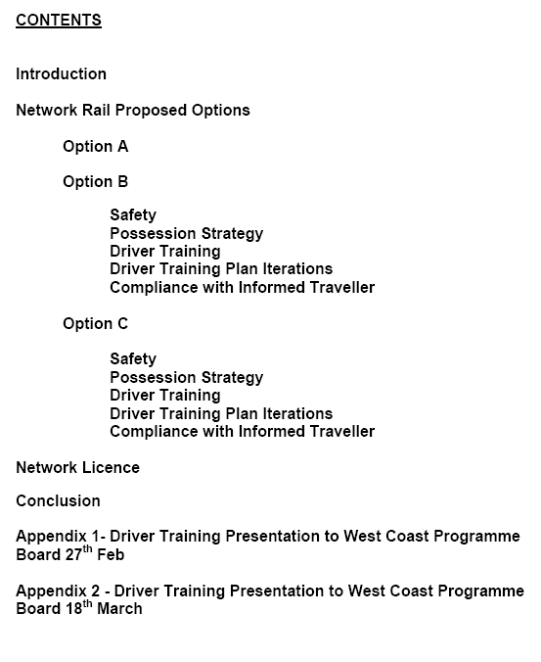

ANNEX “E”
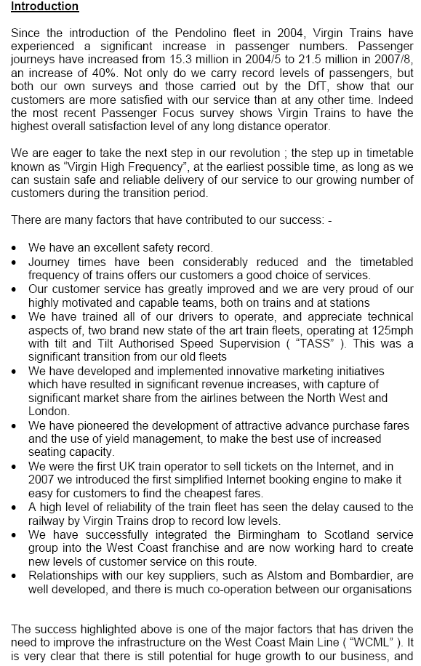

ANNEX “E”

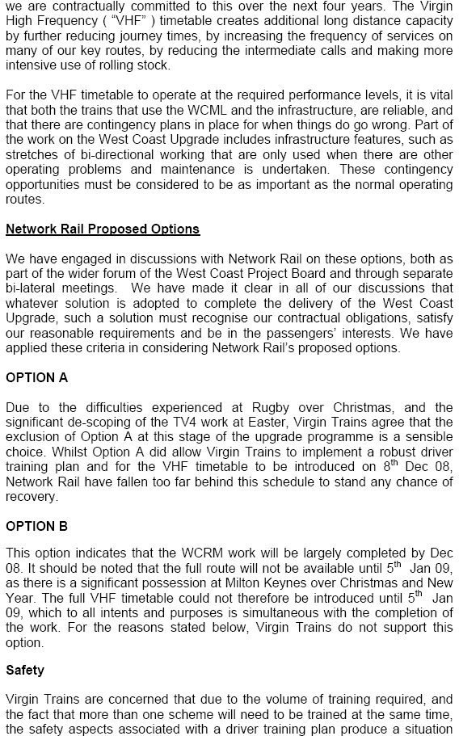

ANNEX “E”

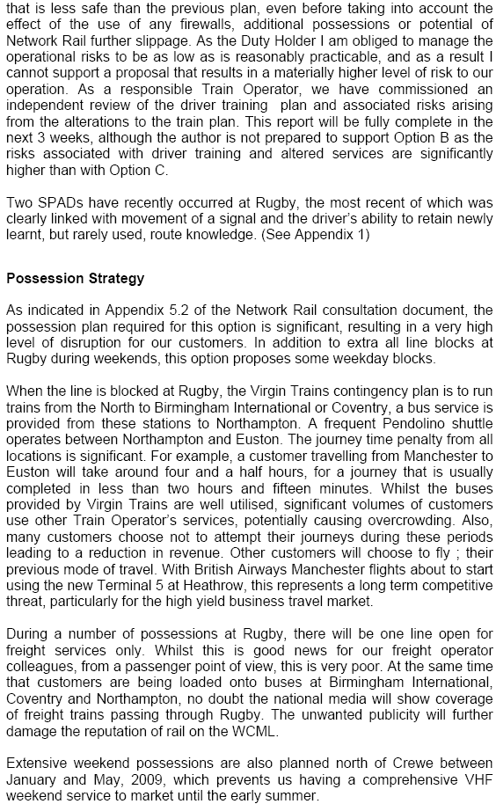

ANNEX “E”

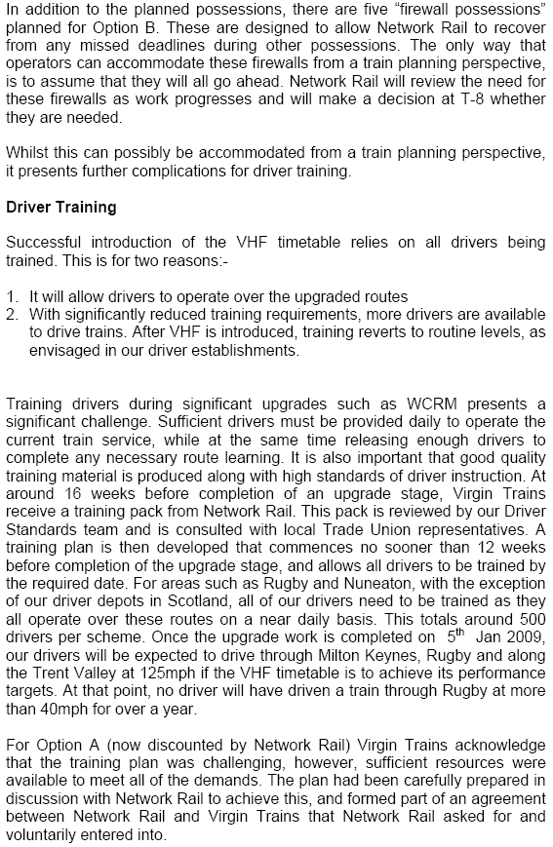

ANNEX “E”

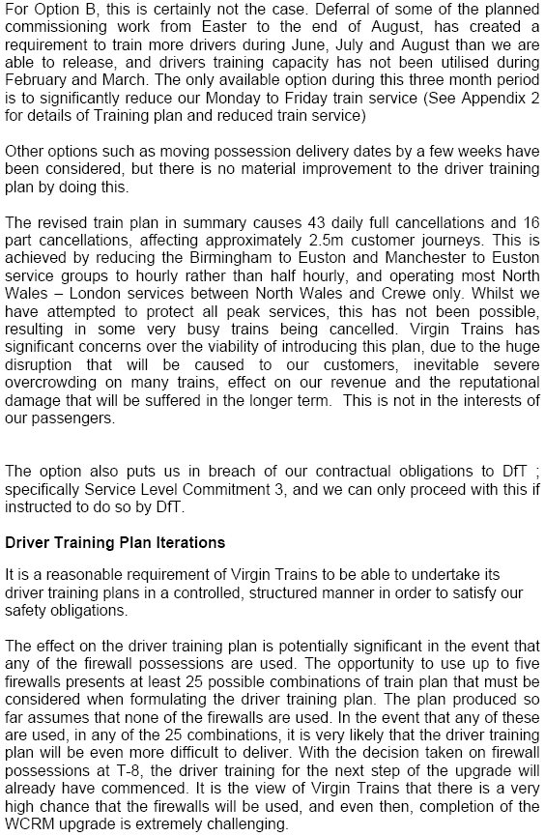

ANNEX “E”

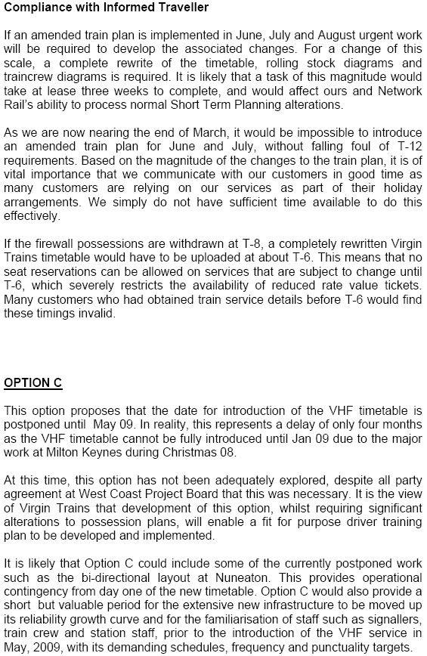

ANNEX “E”

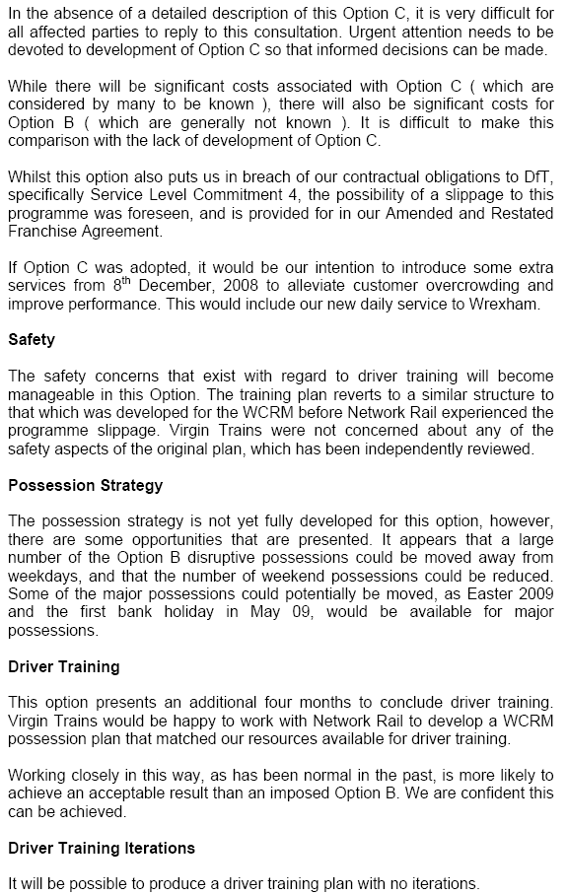

ANNEX “E”

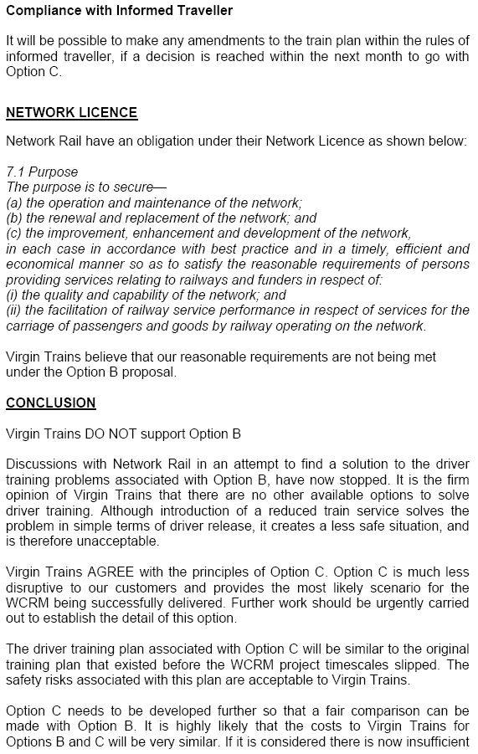

ANNEX “E”

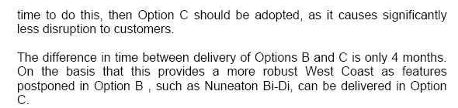

ANNEX “F”

Tuesday 25th March 2008 – Down Standard Hour

ANNEX “F”

Tuesday 25th March 2008 – Up Standard Hour

ANNEX “G”

ANNEX “H”

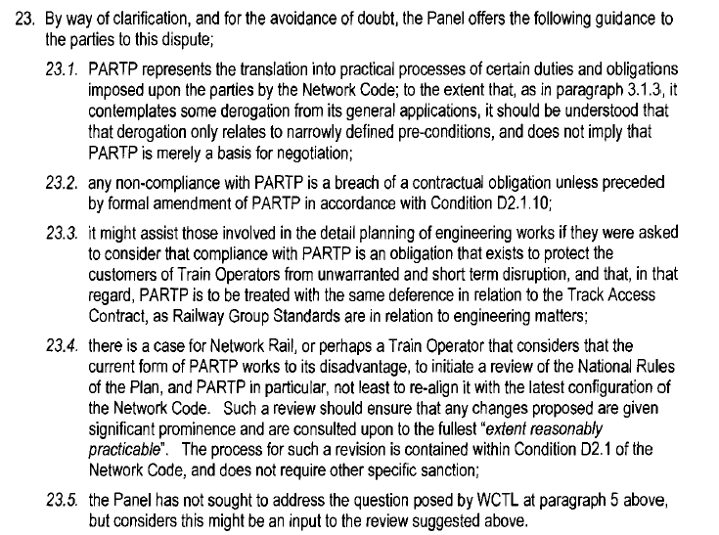

ANNEX “I”

ANNEX “I”
Annex “J”
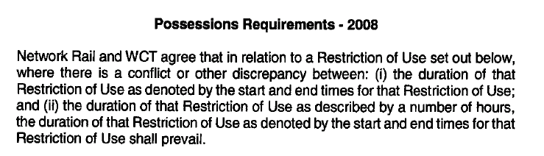
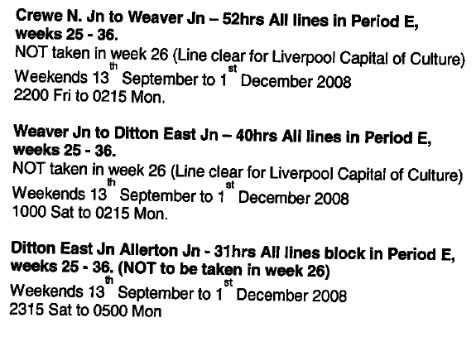

END

