Access Dispute Resolution Rules
Joint Reference
Network Rail / First Greater Western Submission to Timetabling Panel:
TTP95: December 2006 Timetable Offer
(A) Rejection of FGW’s Proposed
Reading - Gatwick 2tph Service.

- details of parties
  - The names and addresses of the parties to the reference are as follows:-
    - First Greater Western Ltd., whose Registered Office is at Milford House, 1 Milford Street, Swindon SN1 1HL (“FGW” ("the Claimant")); and
    - Network Rail Infrastructure Ltd, whose Registered Office is at 40 Melton Street, London NW1 2EE (“NR” (“the Respondent”))

- The Parties’ right to bring this reference
  - This matter is referred to a Timetabling Panel ("the Panel") for determination in accordance with Condition 5.1.1 (b) of Part D the Network Code.
  - The dispute concerns a FGW service aspiration. This was proposed by FGW as part of the timetable development process covering the December 2006 Timetable, and the rejection of the services by Network Rail was undertaken as part of the same timetable development process. The process is facilitated and governed by Part D of the Network Code which is required to be followed by the terms of the track access contract between Network Rail and First Greater Western. Paragraph 5.1.1 of Part D of the Network Code states:

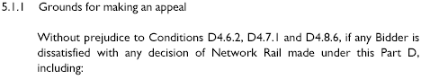

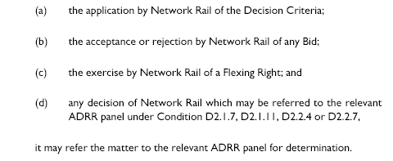
- Contents of reference

The Parties have together produced this joint reference and it includes:-
    - The subject matter of the dispute in Section 4;
    - A summary of the issues in dispute in Section 5;
    - A detailed explanation of the issues in dispute prepared by the claimant with a paragraph by paragraph response from the respondent(s) in Section 6;
    - Any further issues raised by the respondent in Section 7;
    - The decisions of principle sought from the Panel in respect of legal entitlement and remedies in Section 8; and
    - Appendices and other supporting material.

- subject matter of dispute

4.1 This dispute concerns the rejection of aspirations to operate a second train each hour serving Gatwick Airport on the Reading - Redhill / Gatwick route.

This FGW aspiration was new for introduction in December 2006 and is a requirement of FGW’s franchise contract with the DfT. The aspiration was not included in the First Working Timetable Offer from Network Rail. FGW believes that NR has not interpreted the priorities concerned as governed by the Network Code in concluding that the aspirations should not be included in the First Working Timetable Offer.

4.2 Paragraph 3.2.3 of Part D of the Network Code shows the order in which slots should be included in the First Working Timetable, viz:

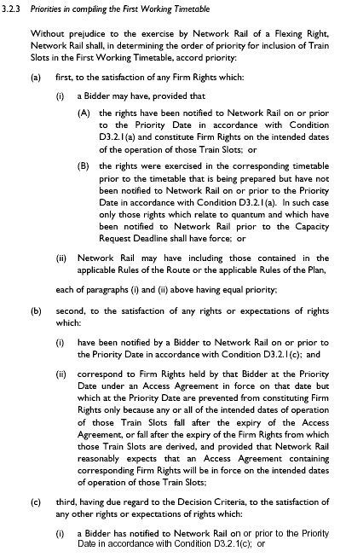

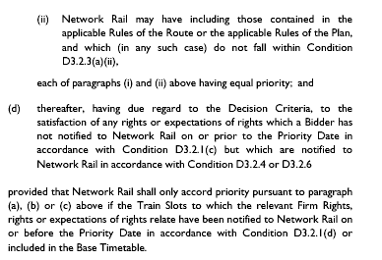

There is no dispute regarding the level of priority that the aspiration should be attributed. The aspirations were new and did not correspond to any preceding rights, therefore the view is that priority 3.2.3 (c) should apply to these trains.

With regard to the Gatwick trains, FGW believes insufficient time has been given to finding a solution that would enable the trains to operate consistent with other operators’ aspirations and rights.

4.3 The aspiration was included in FGW’s Notification to Network Rail made on the Priority Date. This took the form of printed aspirational timetables, annotated existing track access contract extracts, selected rolling stock diagrams; and an extract from the FGW/DfT Franchise Agreement, its Service Level Commitment. Extracts from this Service Level Commitment showing the relevant aspiration is at Appendix A1.

- summary of dispute
  - A log of communication that took place at working level between Network Rail and FGW during timetable development is at Appendix A2.
  - FGW wrote on 21st July to the Secretary of Access Disputes Committee referring this dispute concerning elements of the December 2006 Timetable Offer made by Network Rail on 7th July, using an extract from NR’s letter of 7th July to identify the aspirations in dispute.

An extract from the Offer letter is included in the dispute letter as shown below:
“North Downs (Reading – Gatwick Airport)

The original bid for this service has not proved to be workable between Redhill and Gatwick Airport for SX and SO”

6 explanation of each issue in dispute with response

6.1.1 The current (June 06) service has on Mondays to Fridays and Saturdays two FGW trains per hour between Reading and Redhill via Guildford. One of these each hour continues to Gatwick Airport.

FGW’s aspiration in line with its Franchise requirement from December 2006 was for both trains per hour to continue to Gatwick Airport.

FGW believes that under 3.2.2 NR should give full exhaustive review of the possibilities in seeking to timetable this aspiration, and that the Decision Criteria support this interpretation.

3.2.2 states:

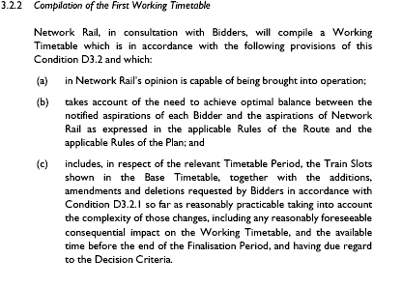

FGW believes the following Decision Criteria support full attention being given to these trains, and shows below each relevant Decision Criteria its rationale for believing this:

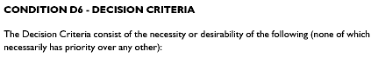

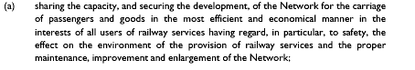

FGW believes that if the second train can reach Gatwick then it eases the way for the withdrawal if through Cross Country services from the Midlands and the North to Gatwick via Reading and either Guildford or Acton. This does not lead to additional resource need for FGW but would release Cross Country resource for deployment elsewhere.

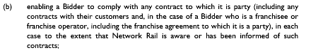

FGW has a franchise contract with the DfT which explicitly requires two trains per hour reaching Gatwick.

FGW believes two trains per hour provide such a frequency that trains can be cancelled or terminated or started short to facilitate prompt restoration of the wtt following perturbation.

Connectional opportunities are much greater at major market of Gatwick. Redhill connections are maintained.

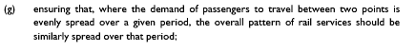

Two trains per hour provide a better spread than one, even if there otherwise exists another with interchange penalty. Connecting services at Reading and Guilford are much more frequent than hourly, so demand is evenly spread.

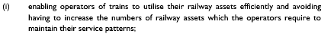

This does not increase FGW resource levels. As indicated above FGW believes it is likely in course to lead to a reduction in the resource need for Cross Country Services, and this FGW understands is provided for in the franchise specification for the new Cross Country franchise.

An enhanced regular frequency in through services to Gatwick from Reading is likely to grow rail’s market share, and potentially use if Gatwick as opposed to other airports.

FGW believes its aspiration will generate income for the industry.

6.1.2 Response to Issue 1 by Respondent.

Network Rail is committed to achieving train operators’ franchise commitments where they are consistent with Part D and the Network Code. Process issues with the letting of franchises allow Network Rail to comment on franchise proposals and in the case of new services there is a commitment to work with the operator to achieve these where there is capacity on the Network and where the performance risk is reasonable. This applied in the case of this aspiration for a half hourly Reading to Gatwick service. Noting part “e” of the decision criteria Network Rail maintains that connections to/from Gatwick are available for passengers arriving at Redhill. As a result a revised service pattern was offered to FGW;
“A revised service is offered for these days after consultation with yourselves. Any further alterations required to this service, will be dealt with through the spot bid process after this offer.”

6.2.1 Whilst NR worked hard to seek a way forward, FGW believes there were still further steps to go which were not it believes undertaken including reviewing any potential solution involving running services empty or loaded south of Gatwick to clear platforms and avoid crossover there.

It also believes the potential solution utilising platform 6 at Gatwick should be offered if it is Rules of the Plan compliant.

6.2.2 Response to Issue 2 by Respondent.
Network Rail invested significant train planning resource in attempting to find paths for these services at a time when that resource was at a premium to develop the December 2006 timetable to Part D timescales. It can be demonstrated that a number of options were looked at in conjunction with First Great Western culminating in a meeting on 21st June 2006 to explain why the 30 minute service could not be accommodated. Notes of this meeting are attached as Appendix A2. The detail discussed included the non-compliances in the original bid and the numerous (Paddington Train Planning quote 5) unsuccessful proposals that had been developed jointly in an attempt to make the service compliant. In all cases the planners found that solving one non-compliance invariably led to others and finally led to the conclusion that the capacity currently does not exist on this route for the proposed service. In terms of man hours, Network Rail believes that approximately 300 were spent on this proposal without success. The evidence of the work undertaken and the discussions that took place over the various proposals are attached as appendix A3.

7 any further issues raised

7.1 Network Rail believes that the background to this franchise commitment rests within the Brighton Main Line RUS which was published in February 2006. If this strategy were introduced then the amended pattern on the Brighton Main Line would, in all probability, have enabled the operation of this service as specified in the FGW franchise commitment.

At present this strategy has not been adopted. An extract of the full 59 page document is attached as Appendix A4.

8 decision sought from the PANEL
    - The Panel is asked by FGW to determine that NR should provide two paths per hour either through utilising platform and/or extending stock southwards to clear the station before making any potentially conflicting moves. Repercussions on calling patterns should be discussed with FGW.

Network Rail believes that the panel should uphold the decision by Network Rail to reject the request for these additional services and that the offered timetable plan should stand.

9 signatures

For and on behalf of Network Rail For and on behalf of First Greater Western

Signed Signed

Print name Print name
Position: Position:

Date: Date:

This is a control mechanism; it provides the panel with the re-assurance that the dispute has been referred with the knowledge and understanding of the disputing corporate bodies. This is important, as engaging in formal dispute resolution implies a commitment to accepting the outcome of that process.
- Appendices and Annexes

A1 FGW Franchise Service Level Commitment (extract)

A2 Minutes of Network Rail/FGW account meeting 21st June 2006

A3 Summary of Train Planning discussions/correspondence

A4 Brighton Line RUS; Executive summary (extract)

