Access Dispute Resolution Rules
Joint Reference
Network Rail / First Greater Western Submission to Timetabling Panel:
TTP95: December 2006 Timetable Offer
(B) Rejection of FGW’s Proposed
London - Slough Peak Service.

- details of parties
  - The names and addresses of the parties to the reference are as follows:-
    - First Greater Western Ltd., whose Registered Office is at Milford House, 1 Milford Street, Swindon SN1 1HL (“FGW” ("the Claimant")); and
    - Network Rail Infrastructure Ltd, whose Registered Office is at 40 Melton Street, London NW1 2EE (“NR” (“the Respondent”))

- The Parties’ right to bring this reference
  - This matter is referred to a Timetabling Panel ("the Panel") for determination in accordance with Condition 5.1.1 (b) of Part D the Network Code.
  - The dispute concerns a FGW service aspiration. This was proposed by FGW as part of the timetable development process covering the December 2006 Timetable, and the rejection of the services by Network Rail was undertaken as part of the same timetable development process. The process is facilitated and governed by Part D of the Network Code which is required to be followed by the terms of the track access contract between Network Rail and First Greater Western. Paragraph 5.1.1 of Part D of the Network Code states:

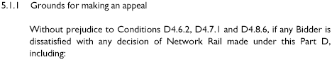

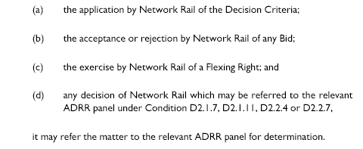
- Contents of reference

The Parties have together produced this joint reference and it includes:-
    - The subject matter of the dispute in Section 4;
    - A summary of the issues in dispute in Section 5;
    - A detailed explanation of the issues in dispute prepared by the claimant with a paragraph by paragraph response from the respondent(s) in Section 6;
    - Any further issues raised by the respondent in Section 7;
    - The decisions of principle sought from the Panel in respect of legal entitlement and remedies in Section 8; and
    - Appendices and other supporting material.

- subject matter of dispute

4.1 This dispute concerns the rejection of aspirations to operate an overlay peak train service between London Paddington and Slough on Mondays to Fridays.

This FGW aspiration was new for introduction in December 2006 and is a requirement of FGW’s franchise contract with the DfT. The aspiration was not included in the First Working Timetable Offer from Network Rail. FGW believes that NR has not interpreted the priorities concerned as governed by the Network Code in concluding that the aspirations should not be included in the First Working Timetable Offer.

4.2 Paragraph 3.2.3 of Part D of the Network Code shows the order in which slots should be included in the First Working Timetable, viz:

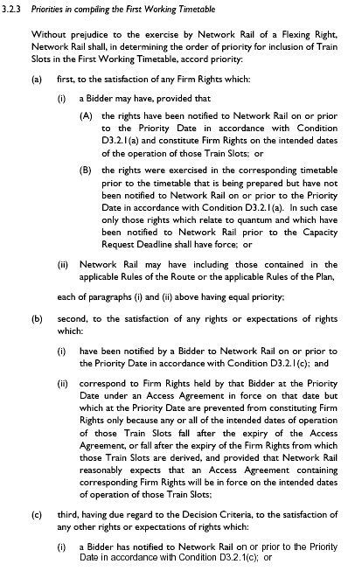

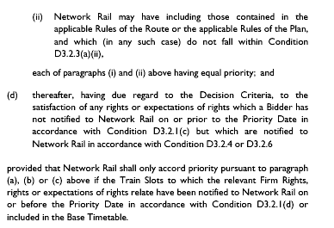

There is no dispute regarding the level of priority that the aspiration should be attributed. The aspirations were new and did not correspond to any preceding rights, therefore the view is that priority 3.2.3 (c) should apply to these trains.

FGW believes NR has misinterpreted the decision criteria (as defined in the Network Code) in concluding the trains should not be included in the Offer.

4.3 The aspiration was included in FGW’s Notification to Network Rail made on the Priority Date. This took the form of printed aspiration timetables, annotated existing track access contract extracts, selected rolling stock diagrams; and an extract from the FGW/DfT Franchise Agreement, its Service Level Commitment. Extracts from this Service Level Commitment showing the relevant aspiration is at Appendix B1.

- summary of dispute
  - A list of rejected trains supplied with the Offer is at Appendix B2.
  - FGW wrote on 21st July to the Secretary of Access Disputes Committee referring this dispute concerning elements of the December 2006 Timetable Offer made by Network Rail on 7th July, using an extract from NR’s letter of 7th July to identify the aspirations in dispute.

An extract from the Offer letter as included in the dispute letter is shown below:
“Thames Valley

“The peak services between Paddington and Slough have been marked as rejected.

“The impact on track capacity by these services has yet to be agreed by Network Rail.”

6 explanation of each issue in dispute with response

6.1.1

The current (June 06) service has on Mondays to Fridays relief line pattern with a standard quarter hourly Paddington - Reading local service combined with a half hourly Paddington - Hayes - Heathrow local service, and a half hourly Paddington - Greenford service. In the peaks there are additional London trains serving Maidenhead, Twyford and the Henley and Bourne End lines.

FGW’s aspiration in line with its Franchise requirement from December 2006 was for this to continue in modified form with a peak service overlay operating between London and Slough.

FGW believes that under 3.2.2 NR should have offered the Rules of the Plan compliant paths identified and not have rejected the trains on the grounds of unidentified potential performance issues, and that the Decision Criteria support this interpretation.

3.2.2 states:

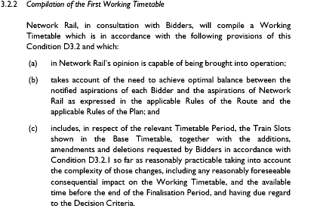

FGW believes the following Decision Criteria support full attention being given to these trains, and shows below each relevant Decision Criteria its rationale for believing this:

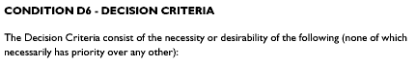

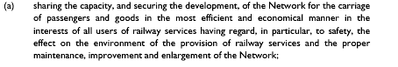

FGW believes that provision of the Slough overlay service is the most efficient method of moving the passenger demand on offer given that alternatives utilising the same level of resources will not provide sufficient accommodation in view of the effect on diagrams of the additional journeys (Reading or Oxford vice Slough) the strengthening units will make. Neither will there be sufficient spread of service to move demand smoothly and with minimum station dwell.

An alternative may be to reduce the longer distance trains to enable greater strengthening which will result in loss of service to outlying stations.

The paths identified are FGW believes Rules of the Plan compliant and thus robust. FGW will consider calling pattern reduction to avoid potential conflict in contra peak flows.

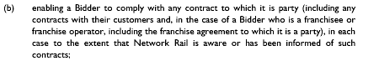

FGW has a franchise contract with the DfT which explicitly requires this service.

The paths identified are FGW believes Rules of the Plan compliant and thus robust. FGW will consider calling pattern reduction to avoid potential conflict in contra peak flows.

FGW believes the increased frequency possible with the overlay service will enable trains to be cancelled or terminated or started short to facilitate prompt restoration of the wtt following perturbation.

Higher frequency implies improved connectional slickness.

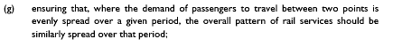

This overlay service will provide a better spread than none.

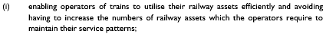

This the most efficient method of providing accommodation sufficient to cater for the business on offer.

Alternatives utilising the same level of resources will not provide sufficient accommodation in view of the effect on diagrams of the additional journeys (Reading or Oxford vice Slough) the strengthening units will make. Neither will there be sufficient spread of service to move demand smoothly and with minimum station dwell.

An alternative may be to reduce the longer distance trains to enable greater strengthening which will result in loss of service to outlying stations.

FGW believes its aspiration will avoid income loss for the industry. It is cost efficient.

6.1.2 Network Rail accepts that the provision of these additional peak time services form part of the FGW Franchise service level commitment (SLC2). However this is not a contractual commitment that is binding on Network Rail though we have had visibility of this commitment and have produced a timetable offer that, wherever possible, is compliant with the SLC2 document.

Network Rail agreed with FGW to undertake a pathing and performance modelling activity with these additional services so that a discussion could take place as to the impact that these services would have on the overall Network Rail and TOC/FOC performance.

A ROTP compliant timetable was produced and this was then modelled using the “RailSys” system. Both parties agreed that this work would be undertaken by RWA and the results became clear in late July /early August.

The results of this study showed that the introduction of the additional services in the morning peak worsened performance by about 4% when compared with the December 2006 timetable that did not include these additional services. At a time when both Network Rail and FGW are under scrutiny over the performance of the timetable it was felt that this was the most important factor in considering the operation of these services. At the franchise steering group meeting held on 28th July 2006 a joint position over these services was agreed that if there was performance worsenment then they would remain rejected. The minutes of this meeting are attached as Appendix B3.

This information was shared with the DfT on the 11th August 2006, The DfT were quite supportive of the methodology and found no reason to question the findings especially when Network Rail confirmed that with the inclusion of all the relevant freight slots and the full effect of Paddington platforms the results would not get any better.

The DfT then wanted to understand from FGW what the capacity impacts of not having these trains in the timetable would be, Network Rail agreed that it will work with FGW to produce a revised train plan.

It is on this basis that Network Rail believes that it was correct in rejecting the bid for these additional services and that this view is supported by Decision Criteria D6 (c), and a revised plan having been developed supported by Decision Criteria D6 (g).

A copy of the RailSys report is attached as Appendix B4 and the notes of the DfT meeting are attached as Appendix B5.

6.2.1 Initial problems regarding paths free of conflict with freight trains has in the main been overcome. FGW believes at the Offer date there is no scope for further analysis and with the information available the Rules of the Plan compliant paths should be offered.

6.2.2 Network Rail agrees that work has been undertaken to ensure that these paths are now compliant with Rules of the Plan, though further work is necessary to finalise the platform working arrangements at Paddington once the finalised resource diagrams are available from FGW.

7 any further issues raised

7.1 Respondent may list any further claim or issue that it wishes to be resolved.

7.2 Response by Claimant.

8 decision sought from the PANEL

8.1 The Panel is asked by FGW to determine that NR should provide the Slough overlay service where Rules of the Plan compliant paths exist (as shown in the list of rejected trains “subject to Route Authority”). In addition it considers where compliant paths for the other legs have since been found these should be timetabled too.

Network Rail asks the panel to uphold the decision it made in the 7th July timetable offer and subsequent meetings with the DfT.

9 signatures

For and on behalf of Network Rail For and on behalf of First Greater Western

Signed sent by email Signed

Print name Richard C Cole Print name
Position: Route Commercial Manager Position:

Date: 31st August 2006 Date:

This is a control mechanism; it provides the panel with the re-assurance that the dispute has been referred with the knowledge and understanding of the disputing corporate bodies. This is important, as engaging in formal dispute resolution implies a commitment to accepting the outcome of that process.

10 Appendices and Annexes

B1 FGW Franchise Service Level Commitment (extract)

B2 List of Rejected Trains

B3 Minutes of Greater Western Steering Group – 28th July 2006

B4 RailSys Performance Modelling Report

B5 Notes of meeting between NR/FGW/DfT 11th August 2006

